**E-Signature User Manual**

Prime Bank PLC.

**User Login**

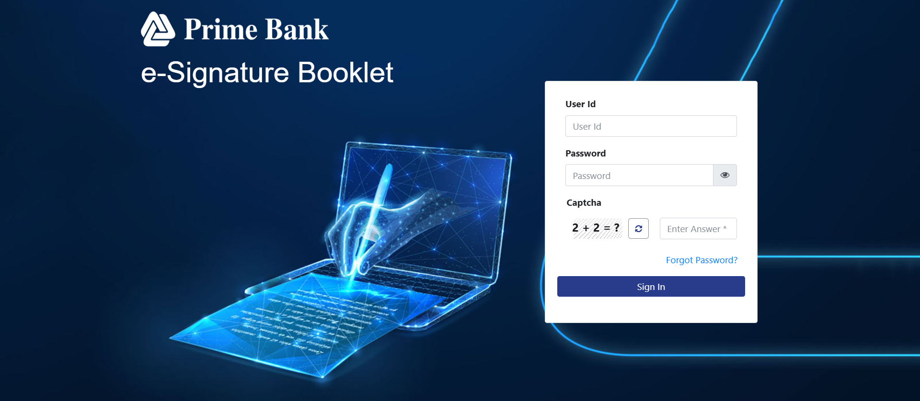

* Log in using your Active Directory (AD) user ID, password, and captcha.

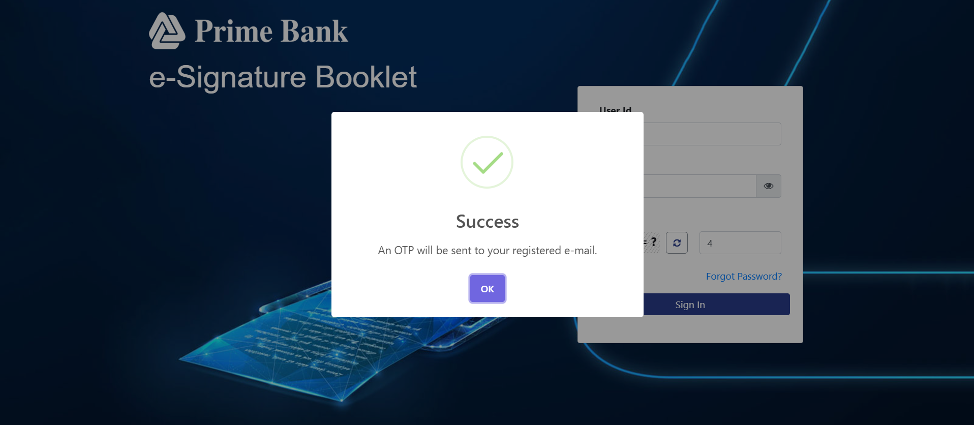

* When the user clicks on Sign In and if the credentials match, an OTP will be sent to their registered email address.

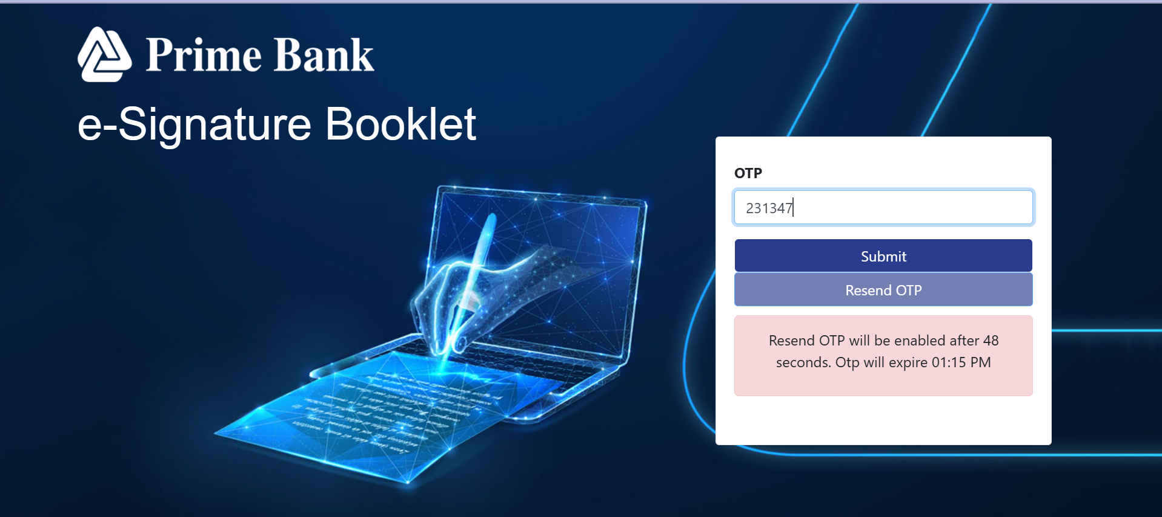

* After entering the correct OTP, the user will be redirected to the main application interface.

**User Unlock**

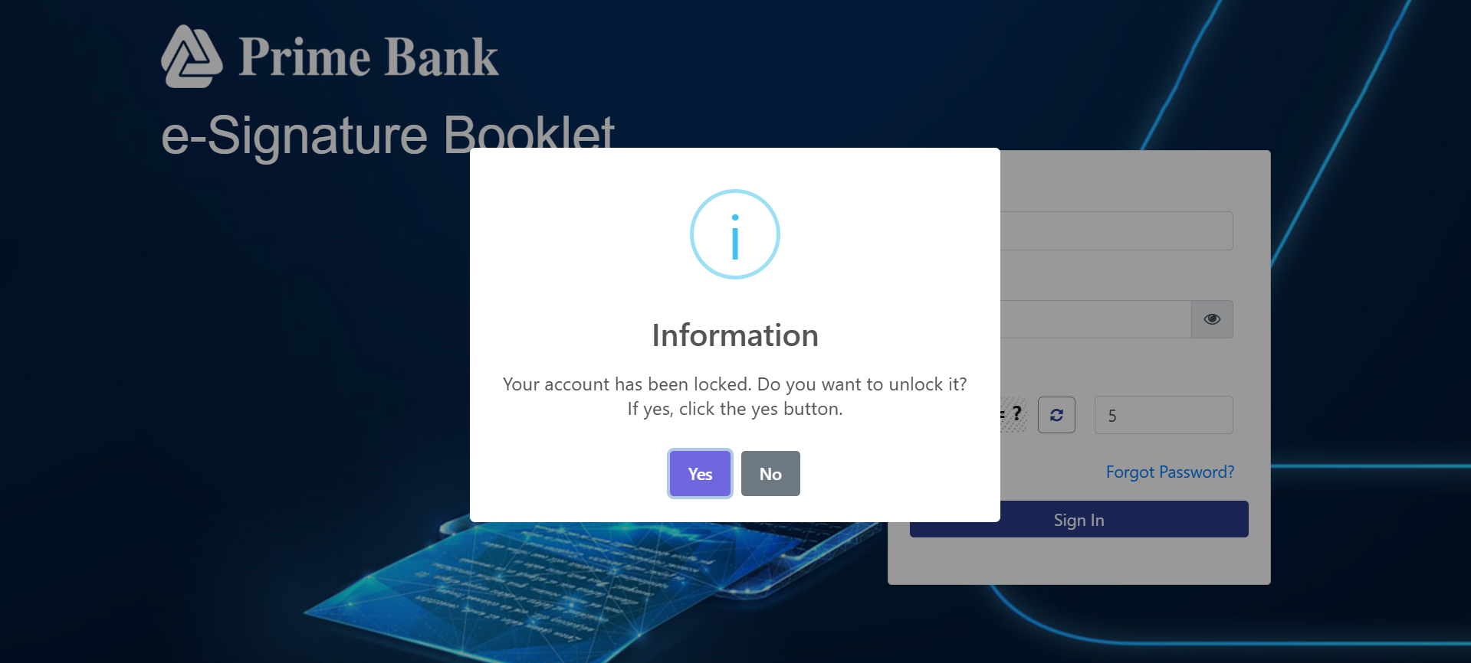

* If a user is locked due to incorrect password attempts, they can **unlock themselves** whether they are **Internal** or **External**.

**For internal user.** 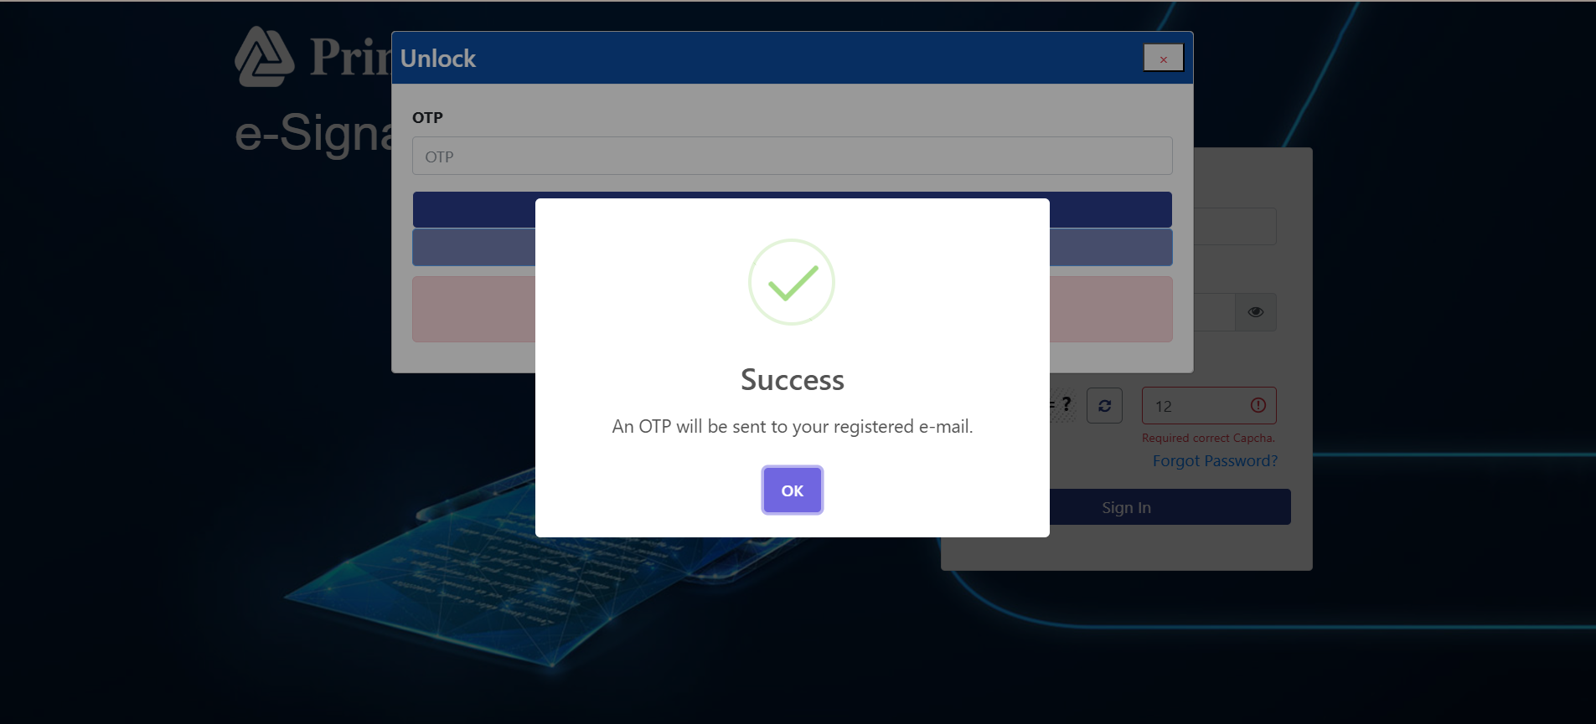

**For external user.**

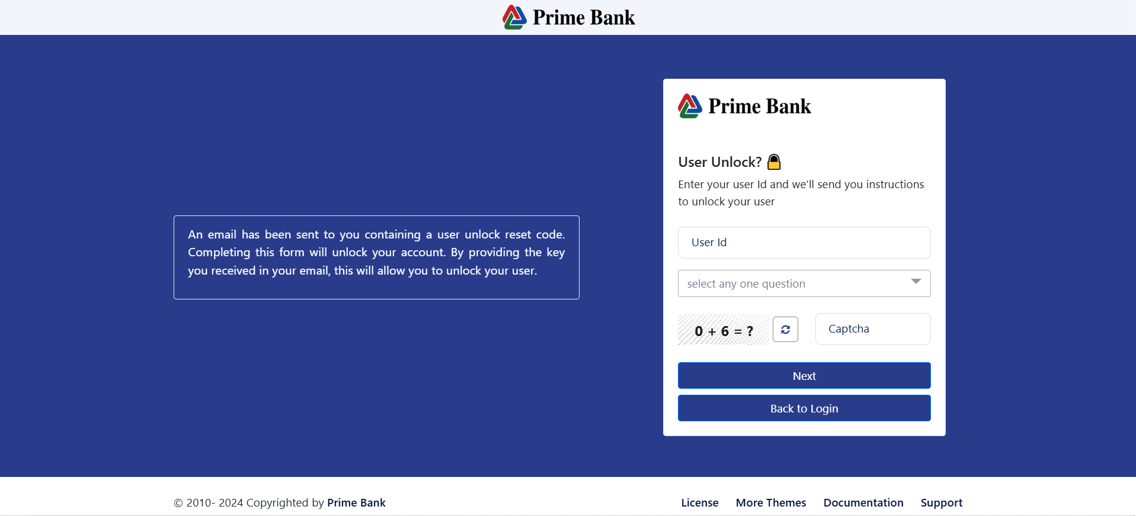

**Forgot Password**

**on Click "Forgot Password" text.** 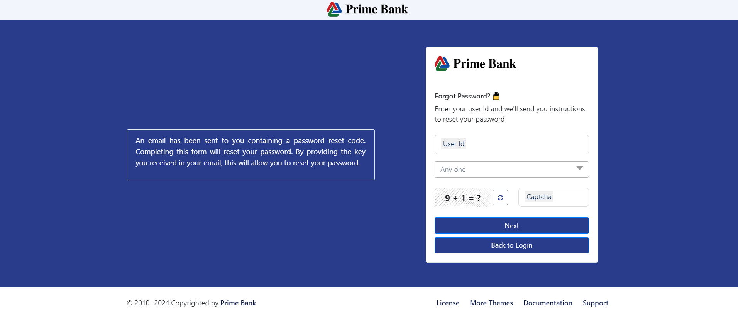

* Enter your user ID, password, and captcha, then click the 'Next' button.
* Click "Back to Login" to return to the login page.

**Complete Reg:**

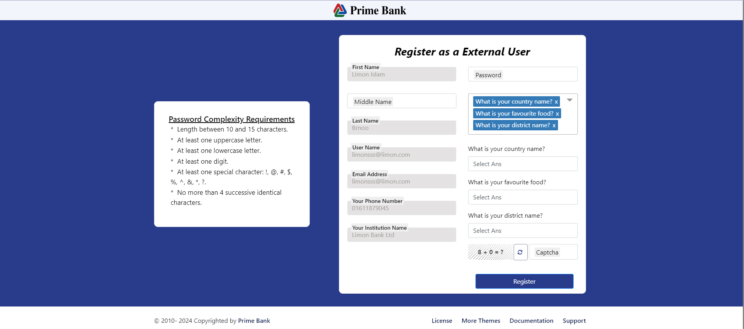

* Input your password and answer the security question, then click 'Register'

**Dashboard:**

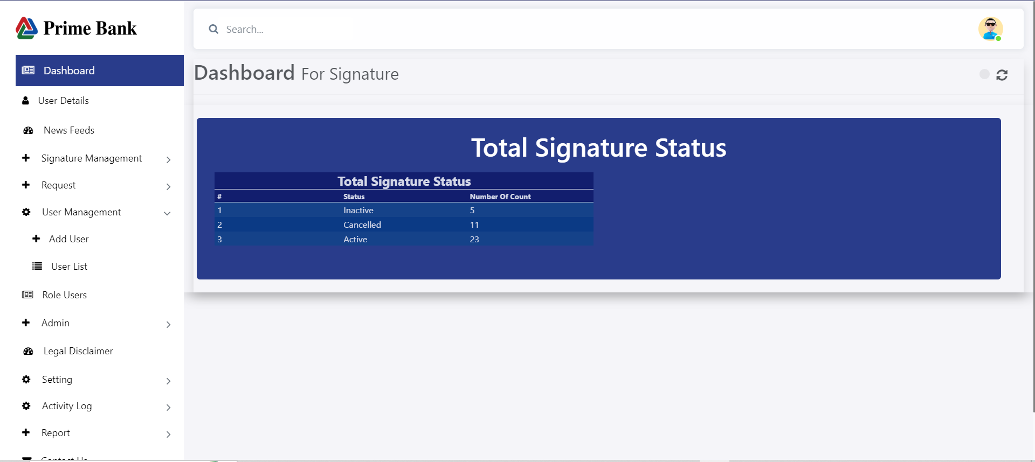

* The dashboard will display the count of active, inactive, and canceled signatures.

**User Details:**

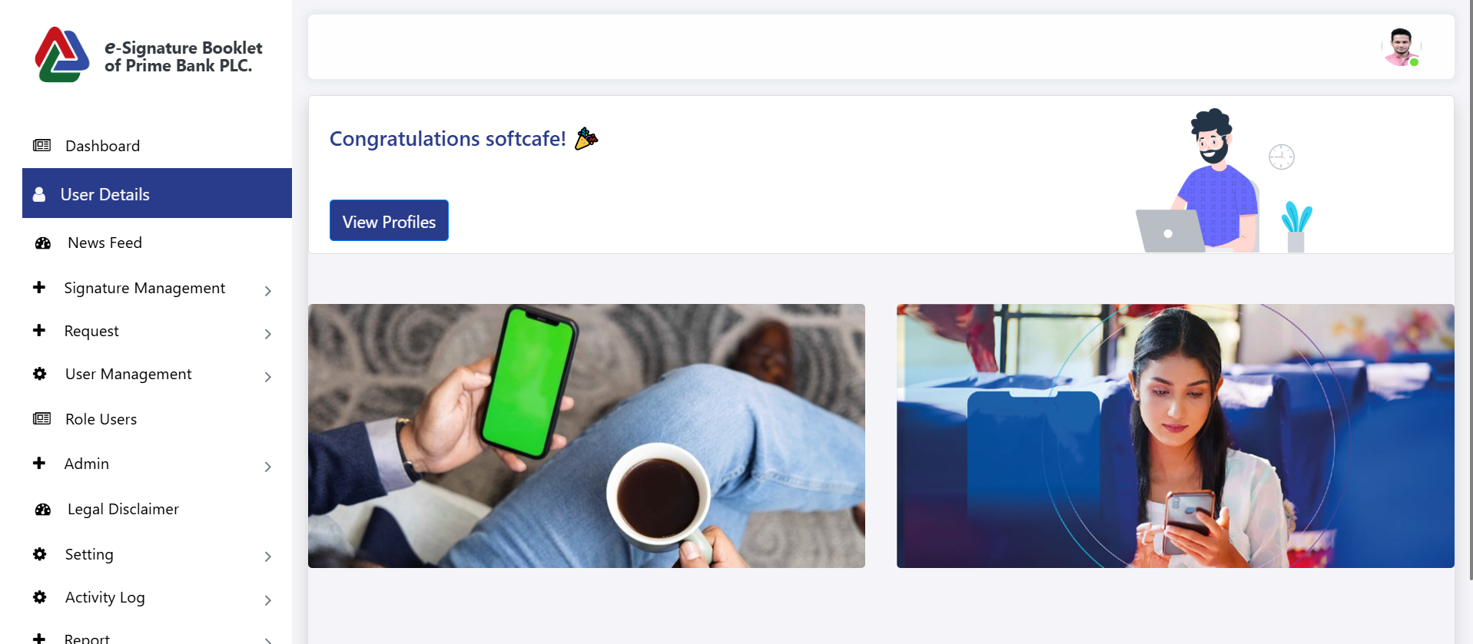

**After click on View profile.**

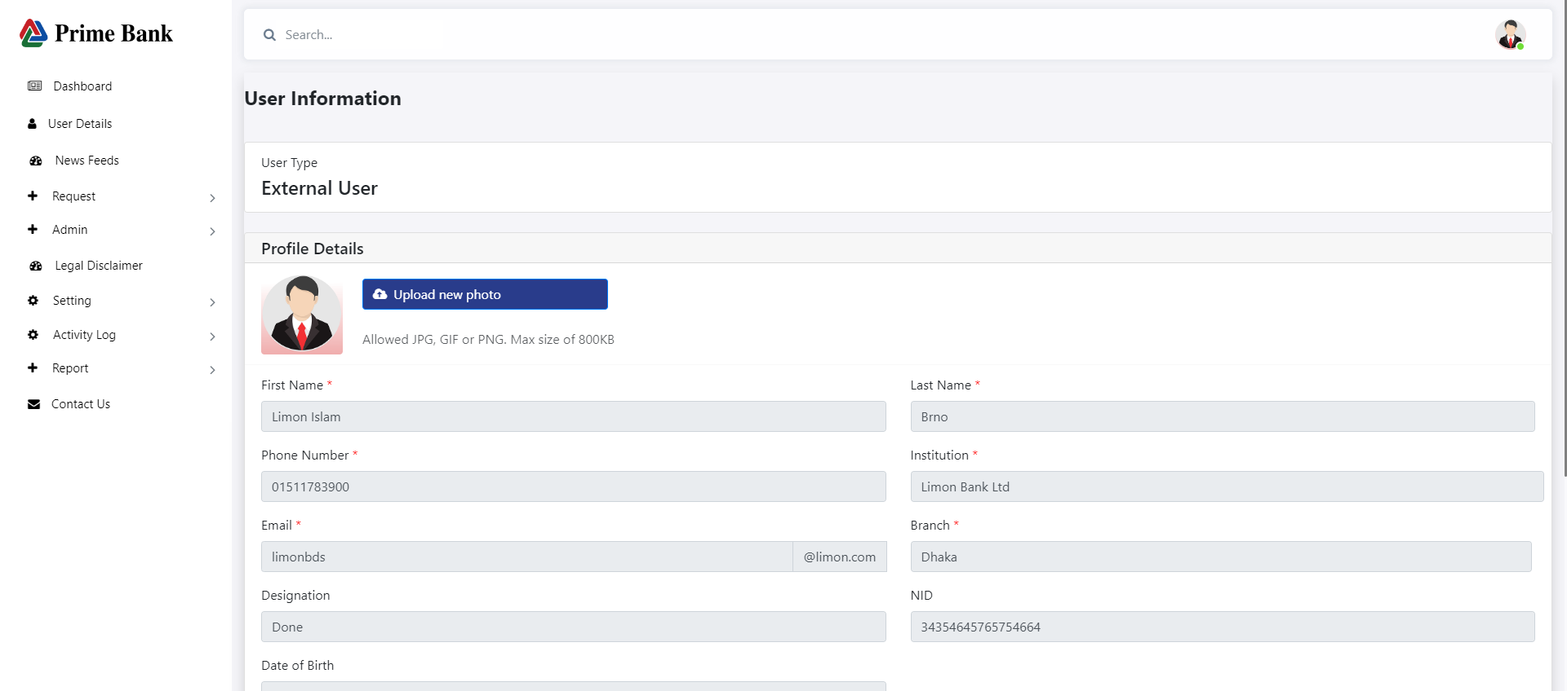

**Profile:**

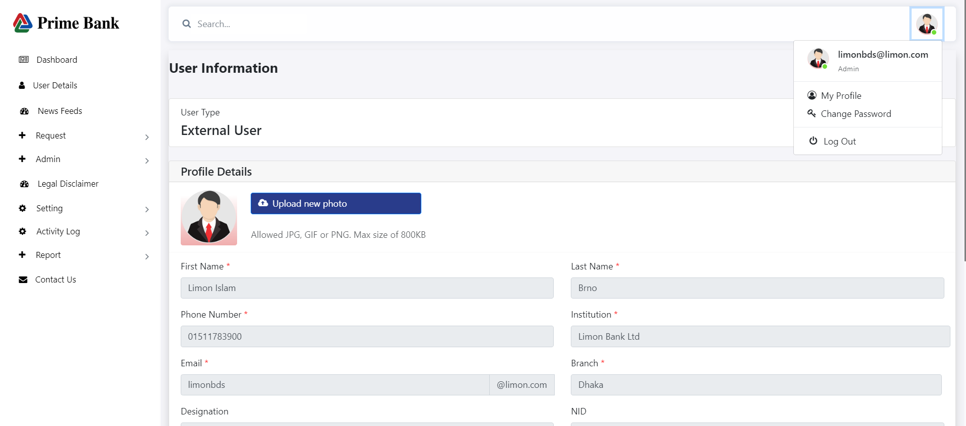

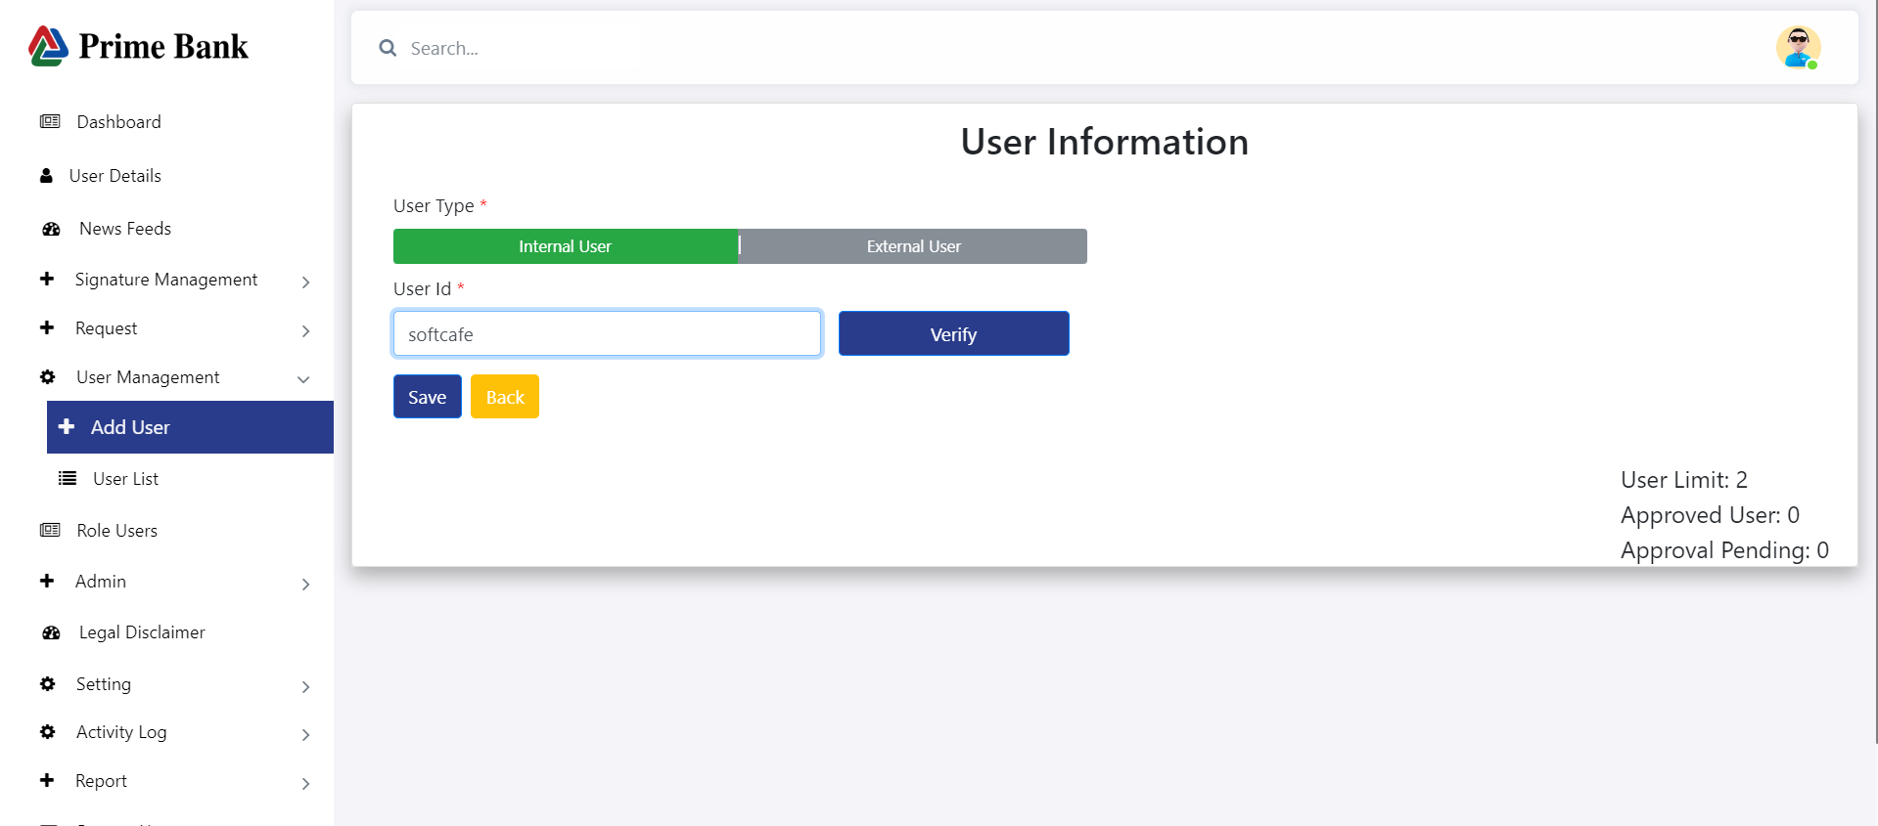

* Click Profile to open the page
* Select the User ID and click on the Verify button.
* Click on the Approved button.

**Change Password:**

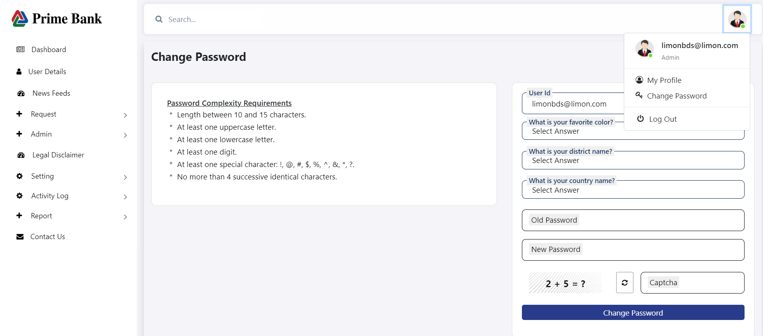

* Click Change Password.
* Fill in all the required fields.
* Click 'Register.

**News Feeds:**

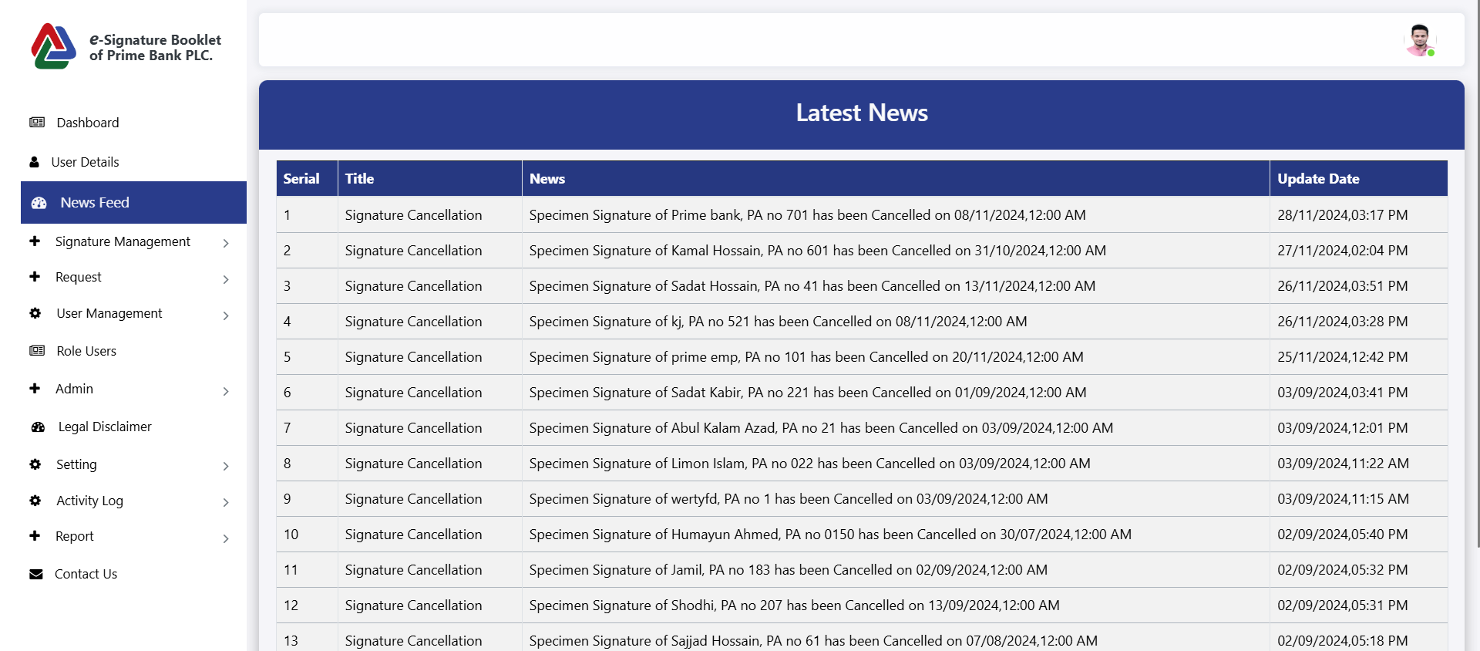

* **Show all cancelation signature news**

**Signature Management**

**Generate Pa:**

**Add Signatory**

**For Prime Bank**

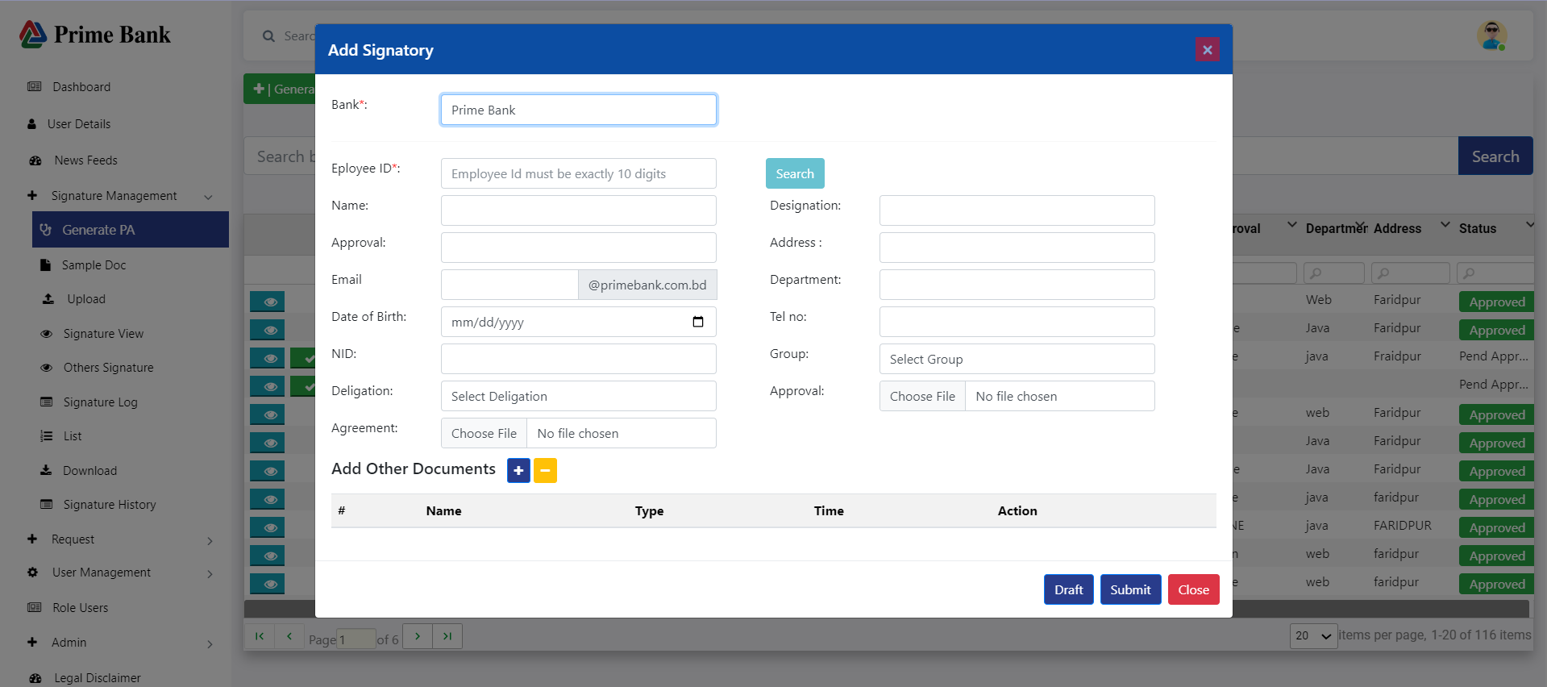

**For Others bank**

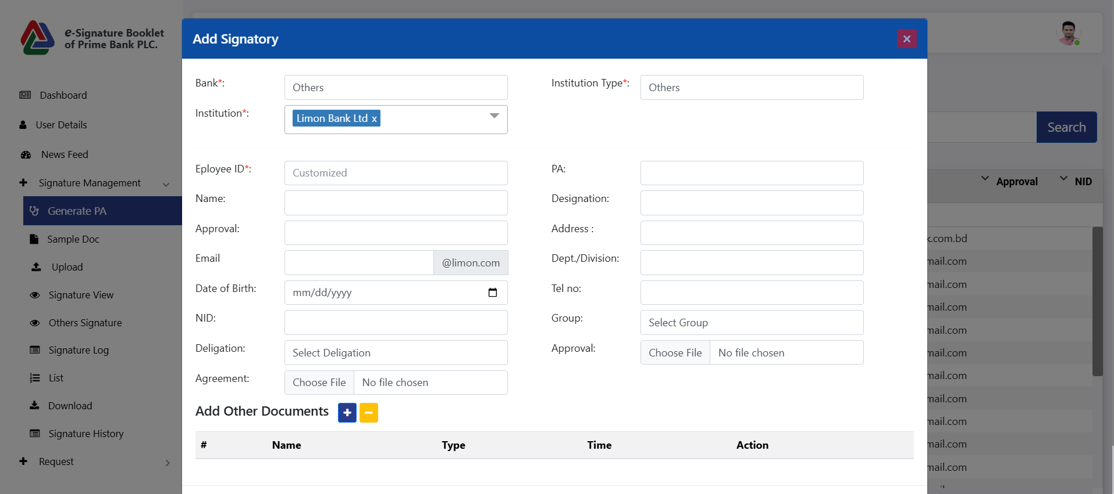

* The user clicks on the PA menu and then clicks the Generate PA Button to open the popup. The user selects the Bank and inputs data in all fields, then clicks the save button to save the value. If the user clicks on the Save and Submit button, it will be authorized by the authorized person.

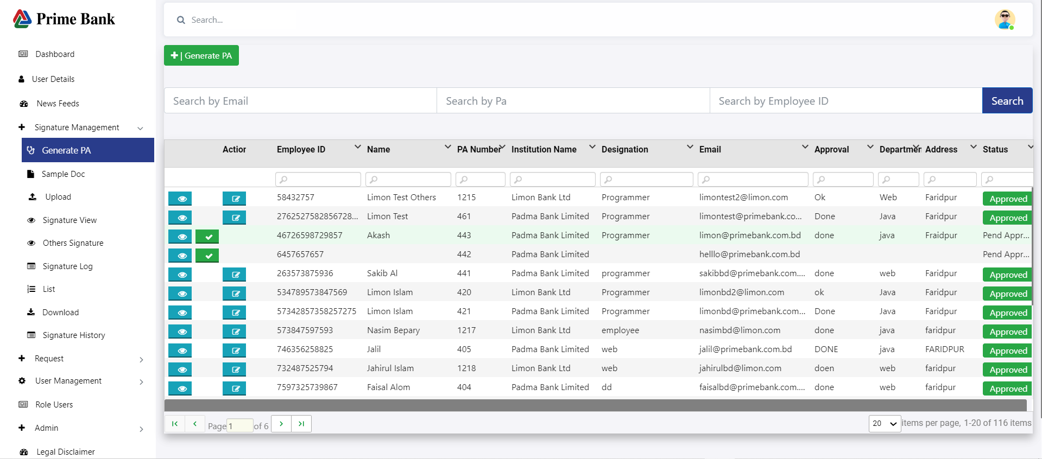

* When the user clicks on the view icon, show the Single PA Data.
* When the user clicks on the tick mark, an approval email is sent.

**Sample Doc:**

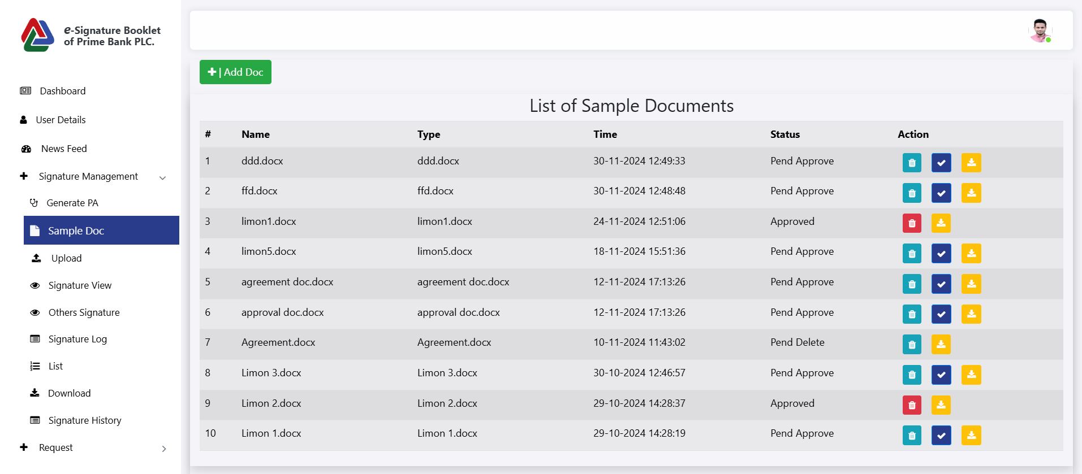

* **When a document is uploaded,** it will move to **Pend Approve**.
* Once approved, the document will be available for use.
* **Click 'Delete'**: The item will move to **Pend Delete**.
* Once the approver confirms the deletion, the item will be **permanently deleted**.
* Click 'Download' to download the document.

**Add Doc**

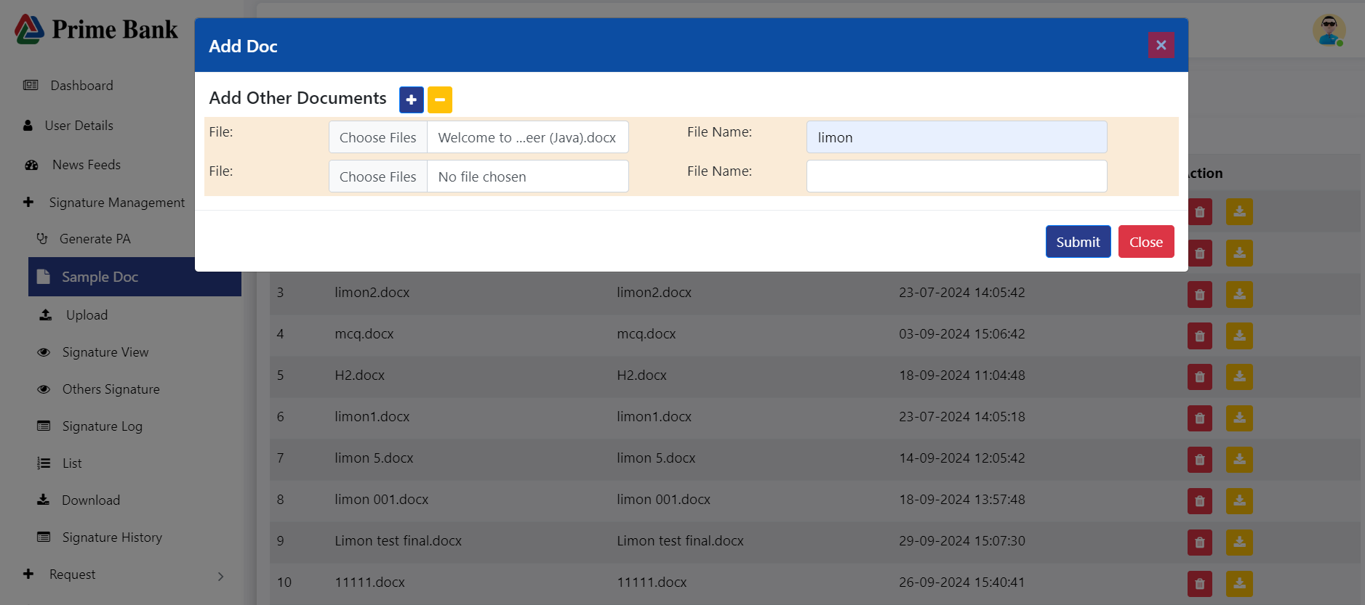

* Click the plus icon to upload another document.
* Click 'Submit' to confirm the upload.

**Upload:**

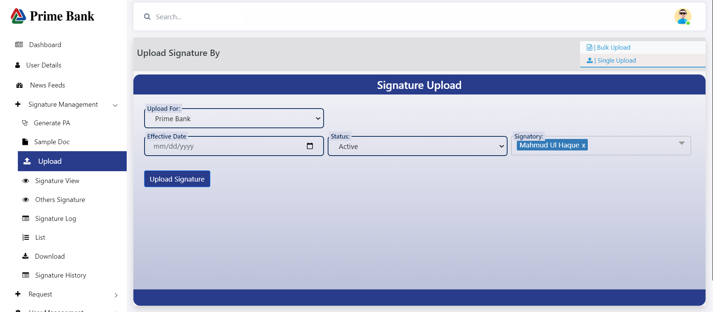

* First, the user clicks on the Signature Management menu, then they click on the Upload menu to select the Single Upload button, which opens the Signature upload page.
* Please select 'Upload' for the field, choose 'Status', and then select 'Signatory'. Finally, click the 'Upload Signature' button.

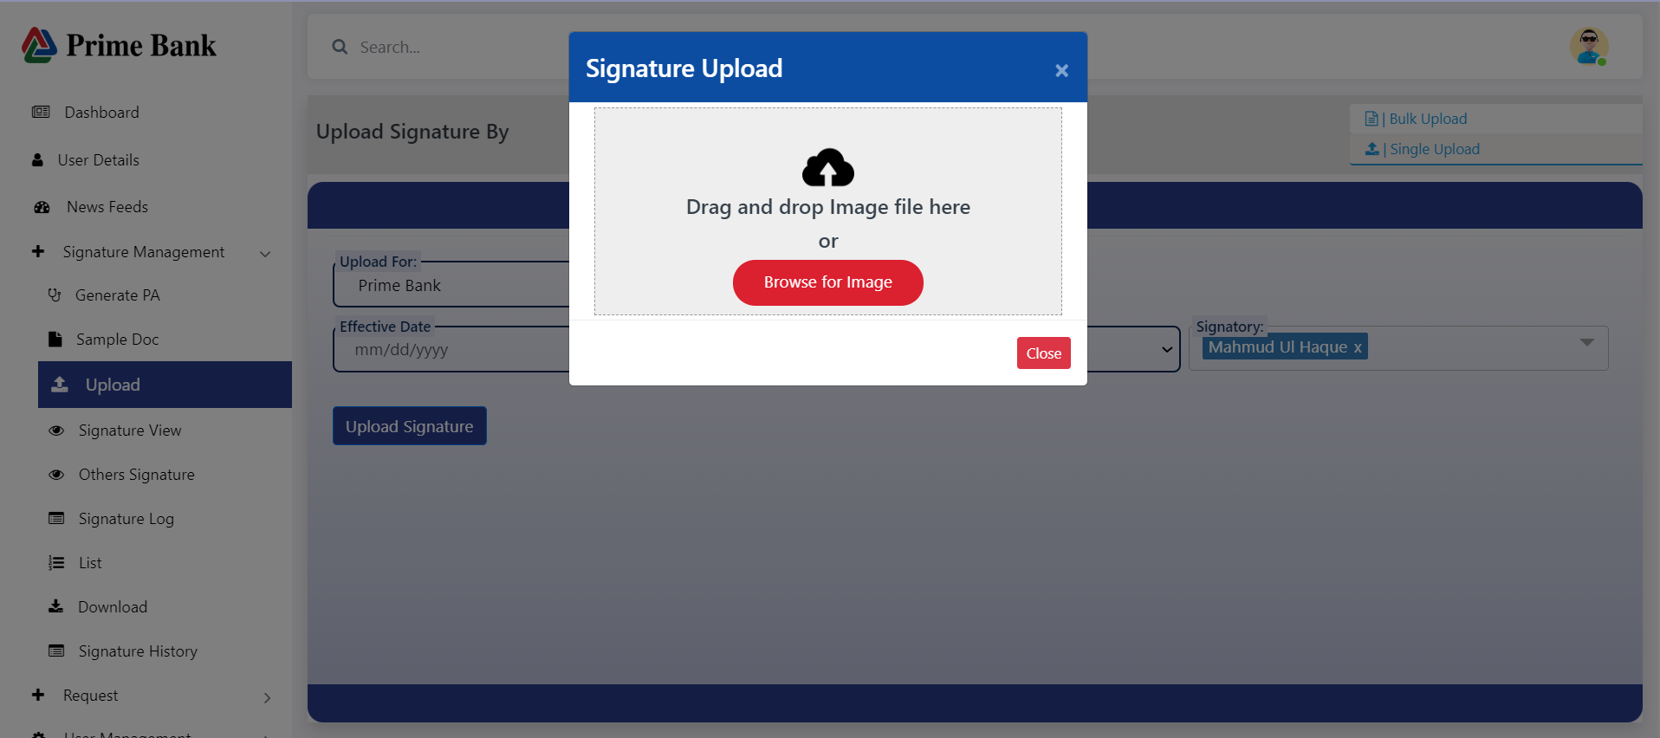

* The user clicked on "Browse for file.

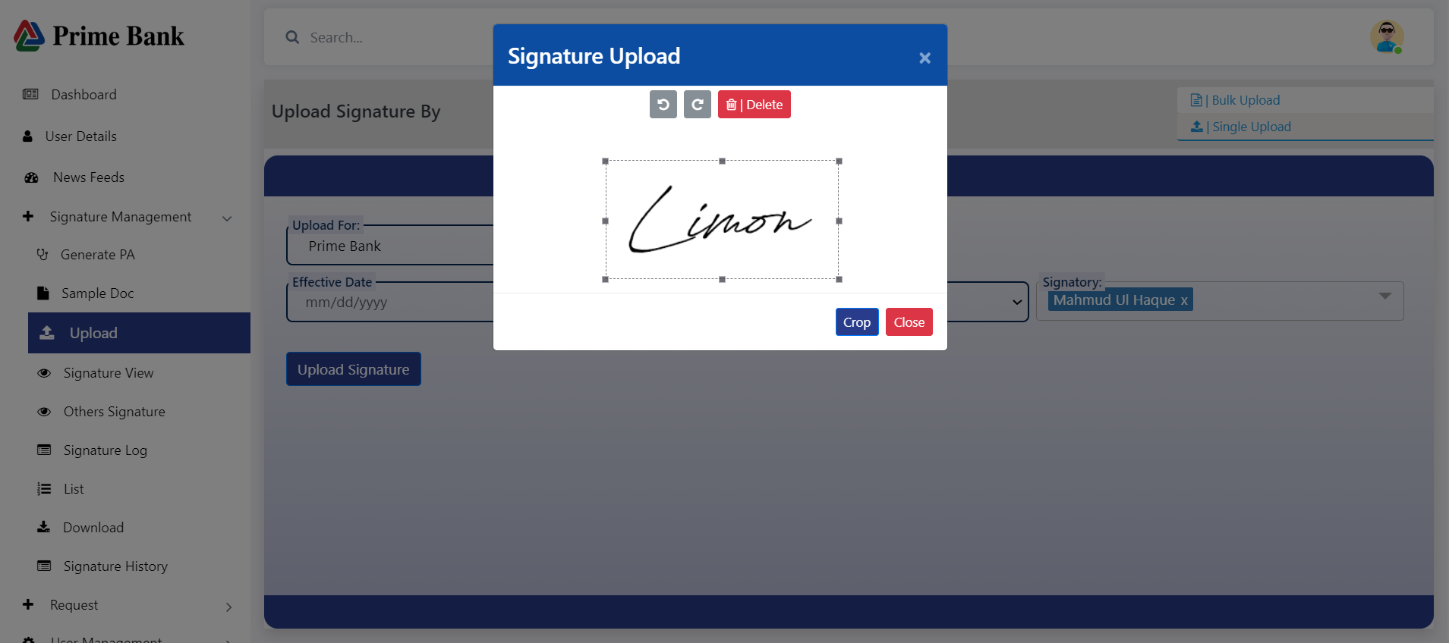

* user clicks on the "Crop Signature" button.

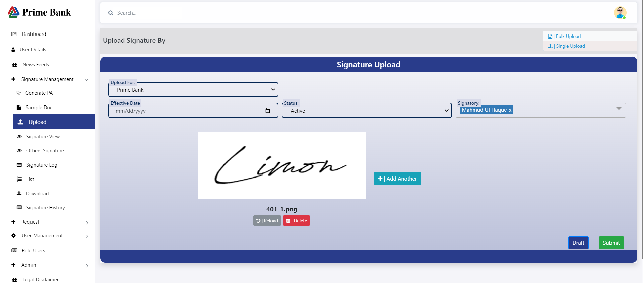

* The user wants to upload more signatures. Click on the 'Add Another' button then Click on Sava Signature button.
* To delete the signature, click the delete button.
* To Reload the signature, Click the Reload button.

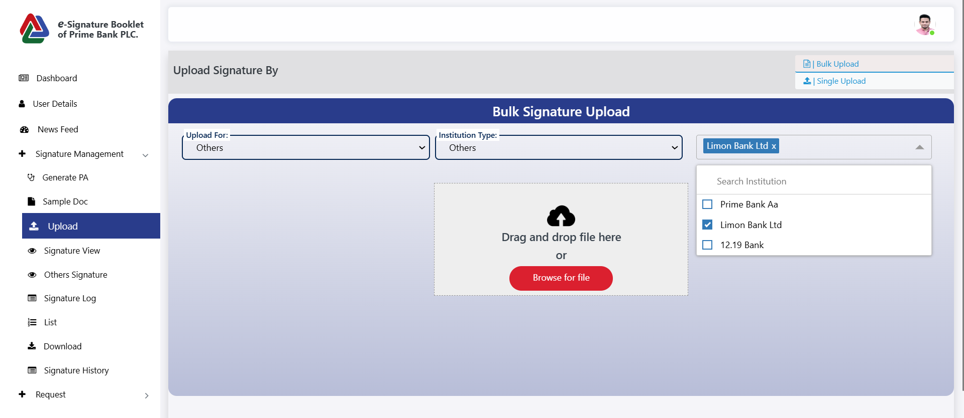

* First, the user clicks on the Signature Management menu, then they click on the Upload menu to select the Bulk Upload button, which opens the Signature upload page.
* Please select 'Upload' for the field, choose ' Institution Type', and then select ' Institution Name'. Finally, click the 'Browse for file ' button then Choose the file.

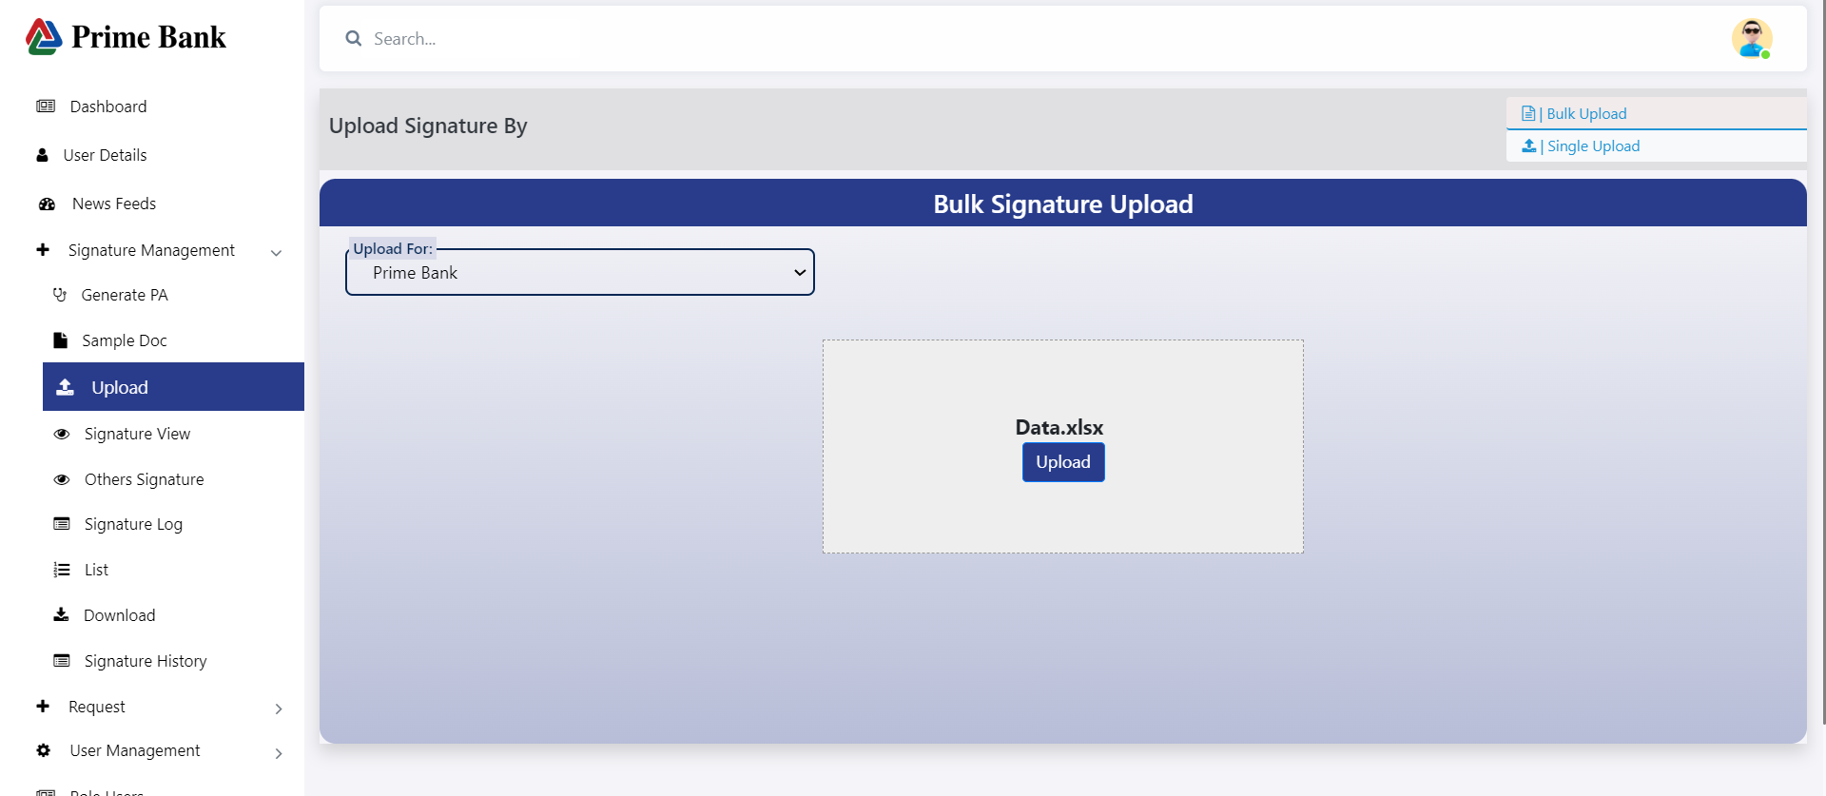

* User clicks on the Upload button, and then the file upload is complete.

**Signature View:**

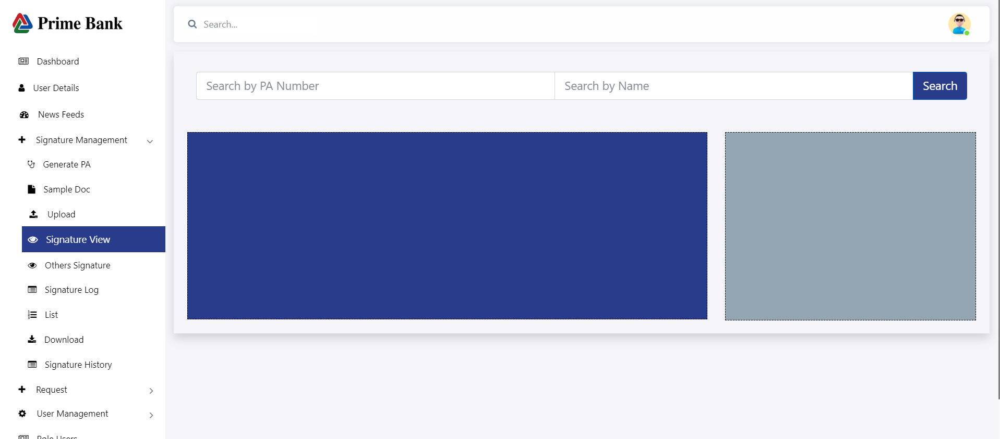

* The user first clicks the View menu, then inputs the PA number or name, and clicks the Search button. Finally, the signature and signature information are displayed.

**Other Signature View:**

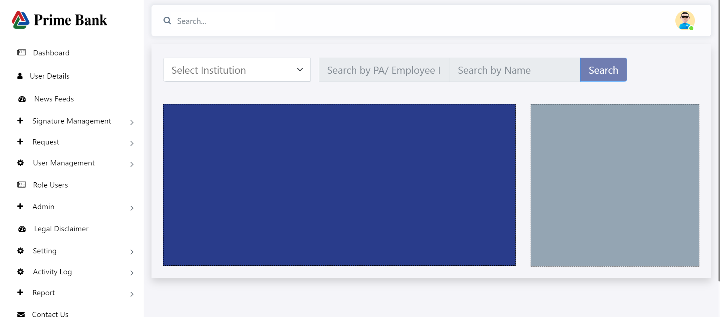

* Select an institution; otherwise, the other two input fields will be disabled.

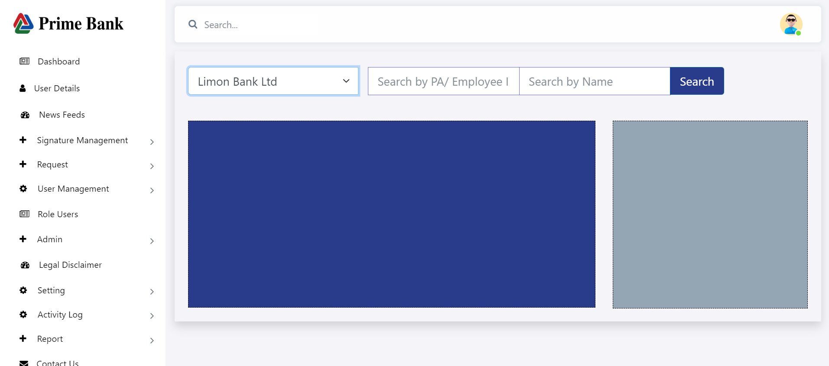

* The user first clicks the View menu, then select institution and inputs the PA number or name, and clicks the Search button. Finally, the signature and signature information are displayed.

**Signature Log:**

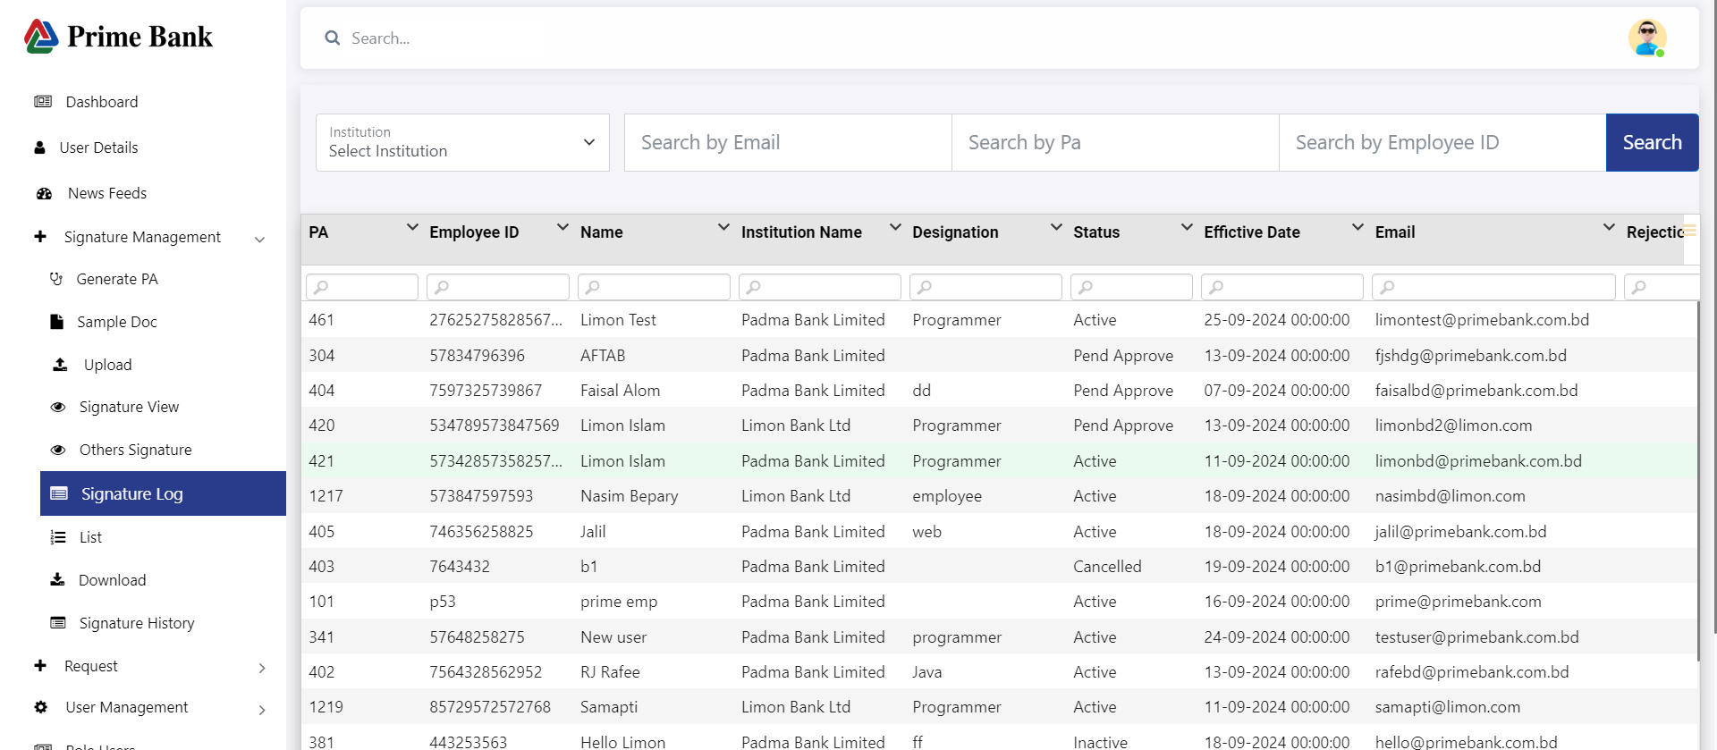

* The user clicks on Signature Log to show all Signature Information.

**Signature List:**

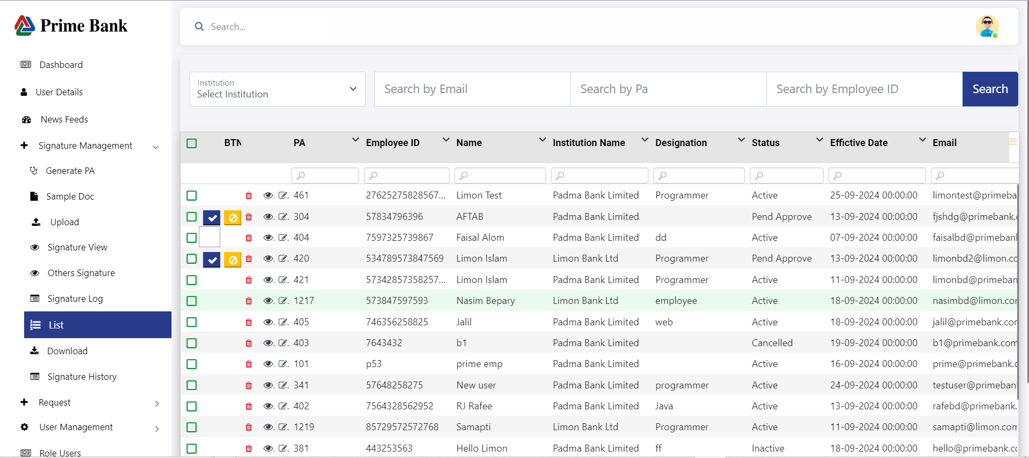

* First, the user clicks on the 'Signature Management' menu, then selects 'List' to display all signature data.
* The user clicks the checkmark to approve the uploaded signature.
* When the user clicks the view icon, a detailed piece of information is displayed.
* Click the delete icon to remove the entry

**Download:**

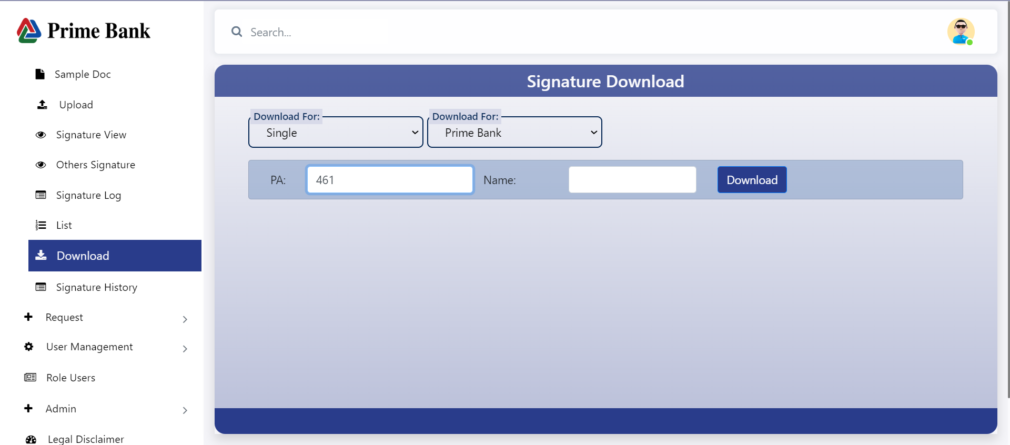

* + First, click the download menu.
  + Select 'Download for.'
  + If 'Download for' is set to 'Single,' input the other fields.
  + If 'Download for' is set to 'Full Booklet,' there will be no option to input additional information

**After click on download**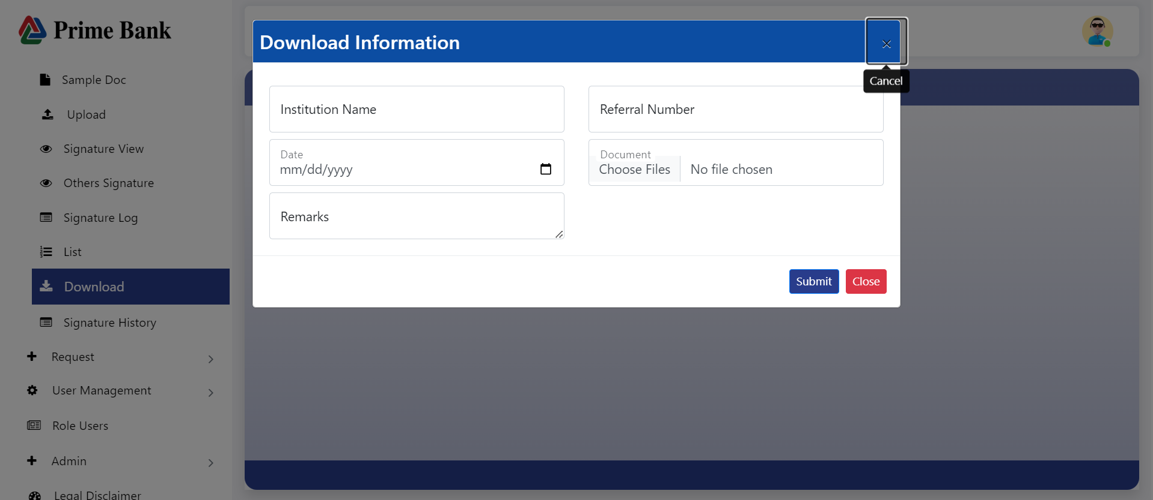

* A download information form will be displayed.

**Signature History:**

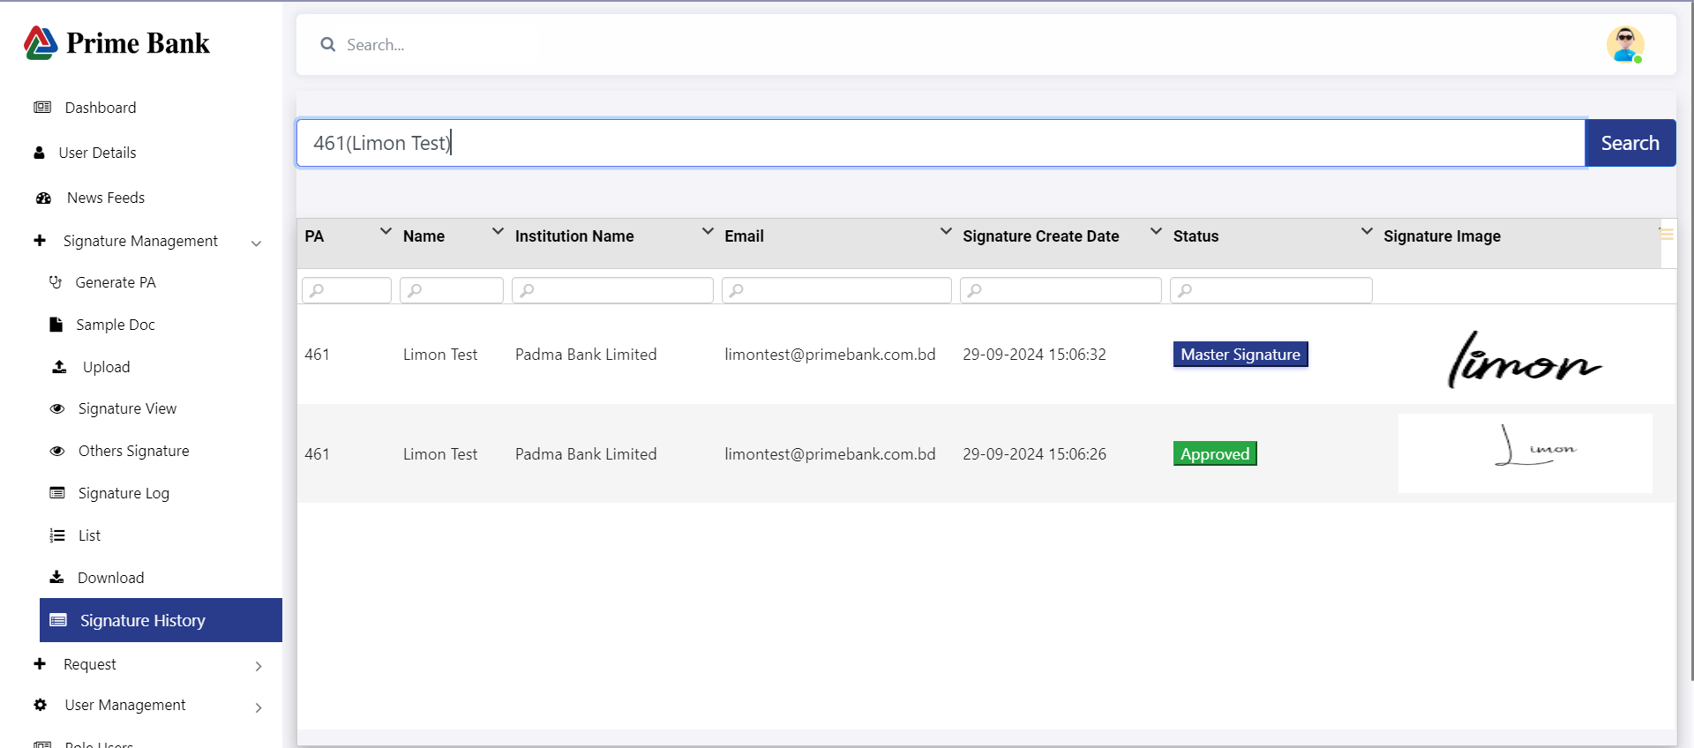

* Click on 'Signature History, then search for PA/name to display the signature data.

**Request :**

* Click on the 'Request' menu, then click the 'Add Request' button. Select the Type, input all data, and click the 'Save' button.

**Request of Booklet**

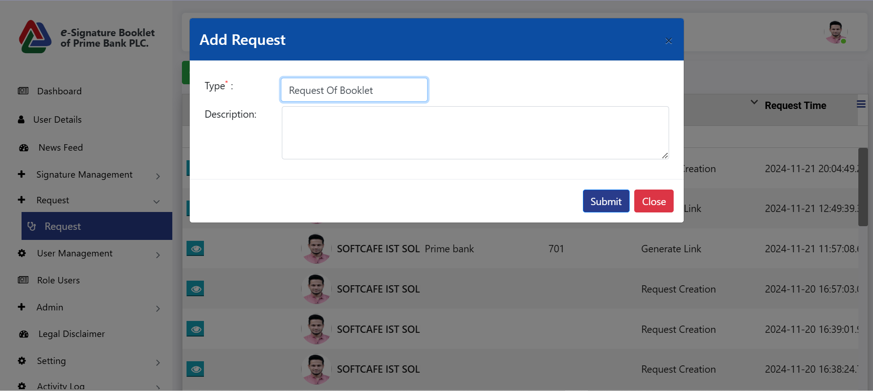

* Here, users can submit a request for a booklet.

**Request of verify signature**

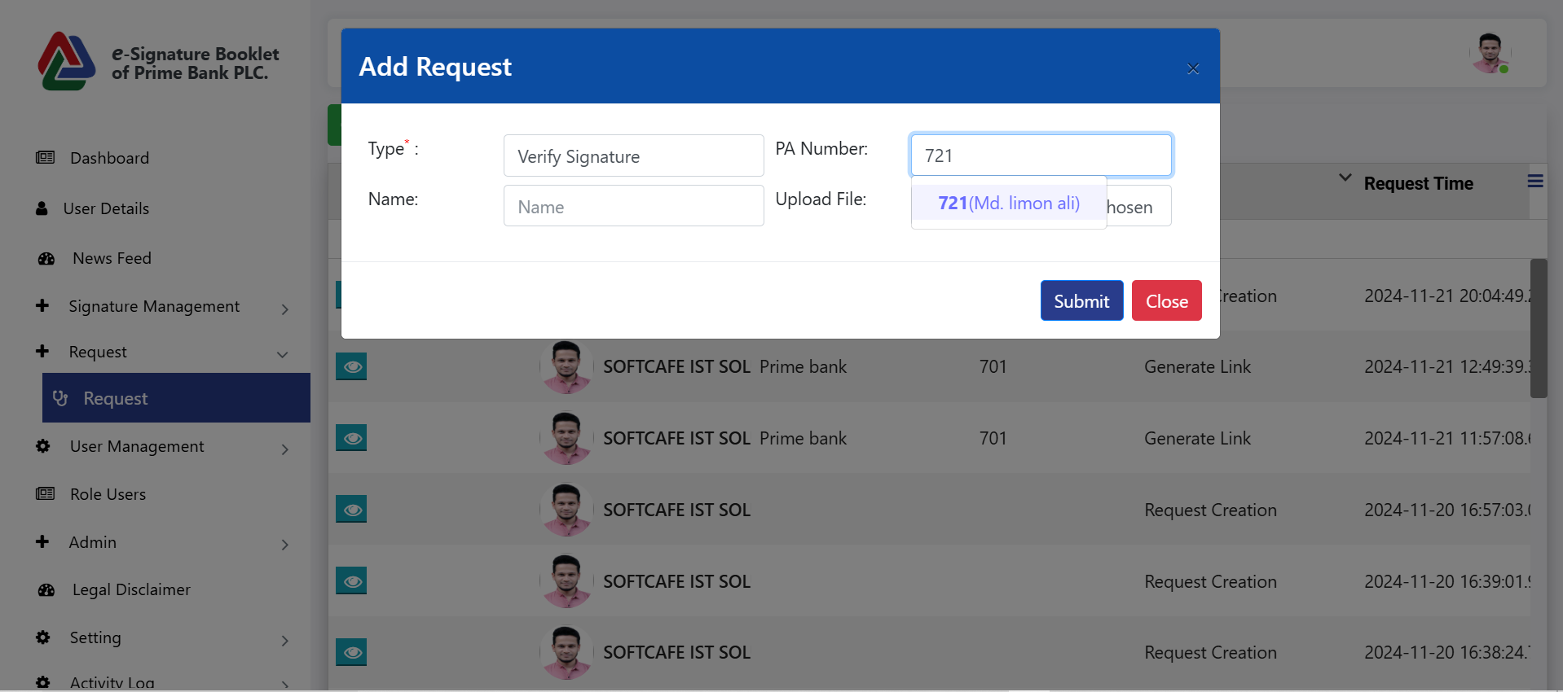

* Here, users can verify their signature

**Request Creation**

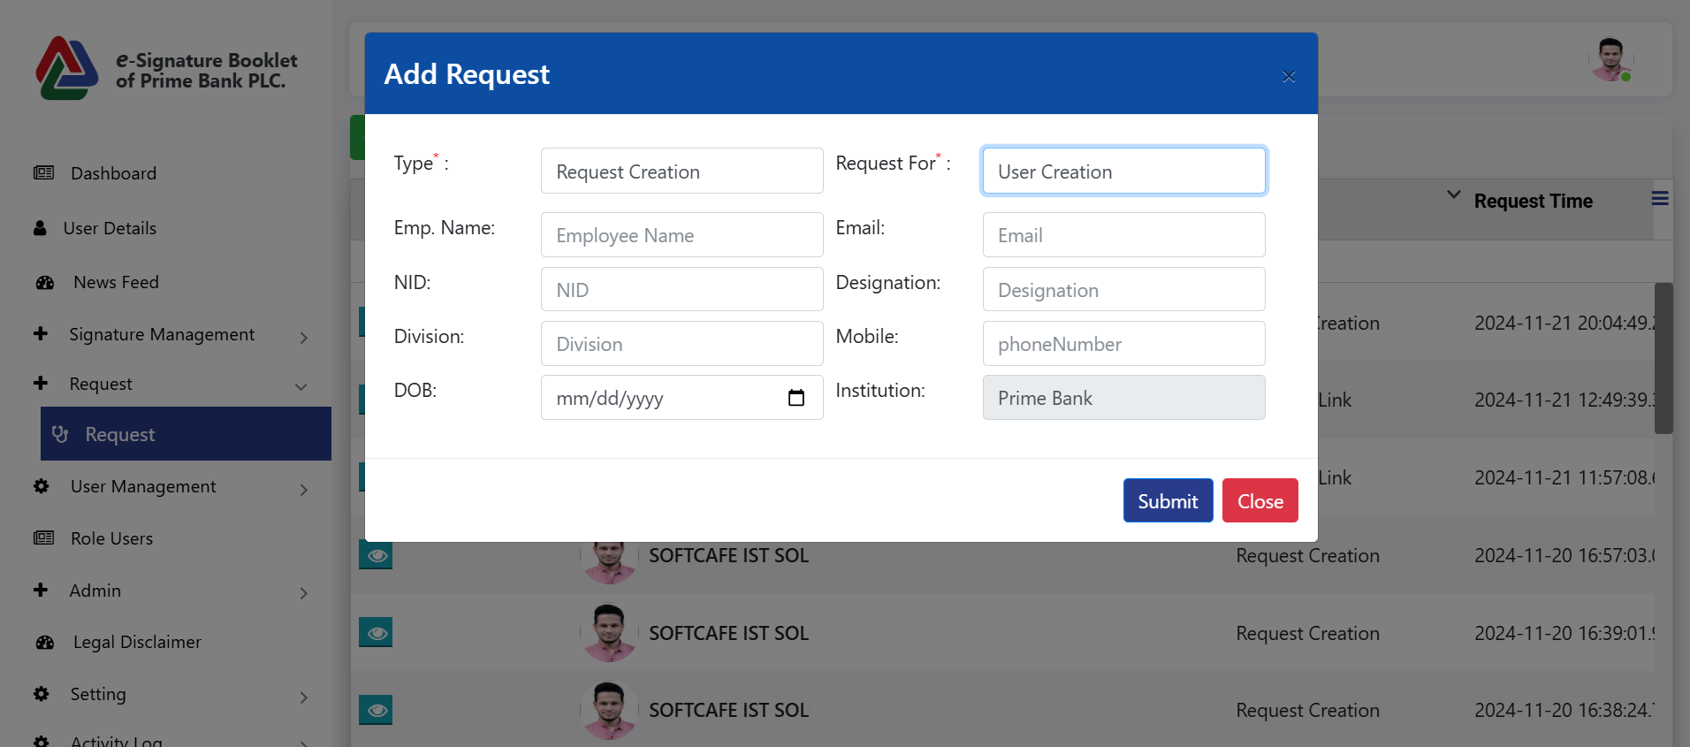

* Here, users can request the creation of a new user account.

**Request for User Activation**

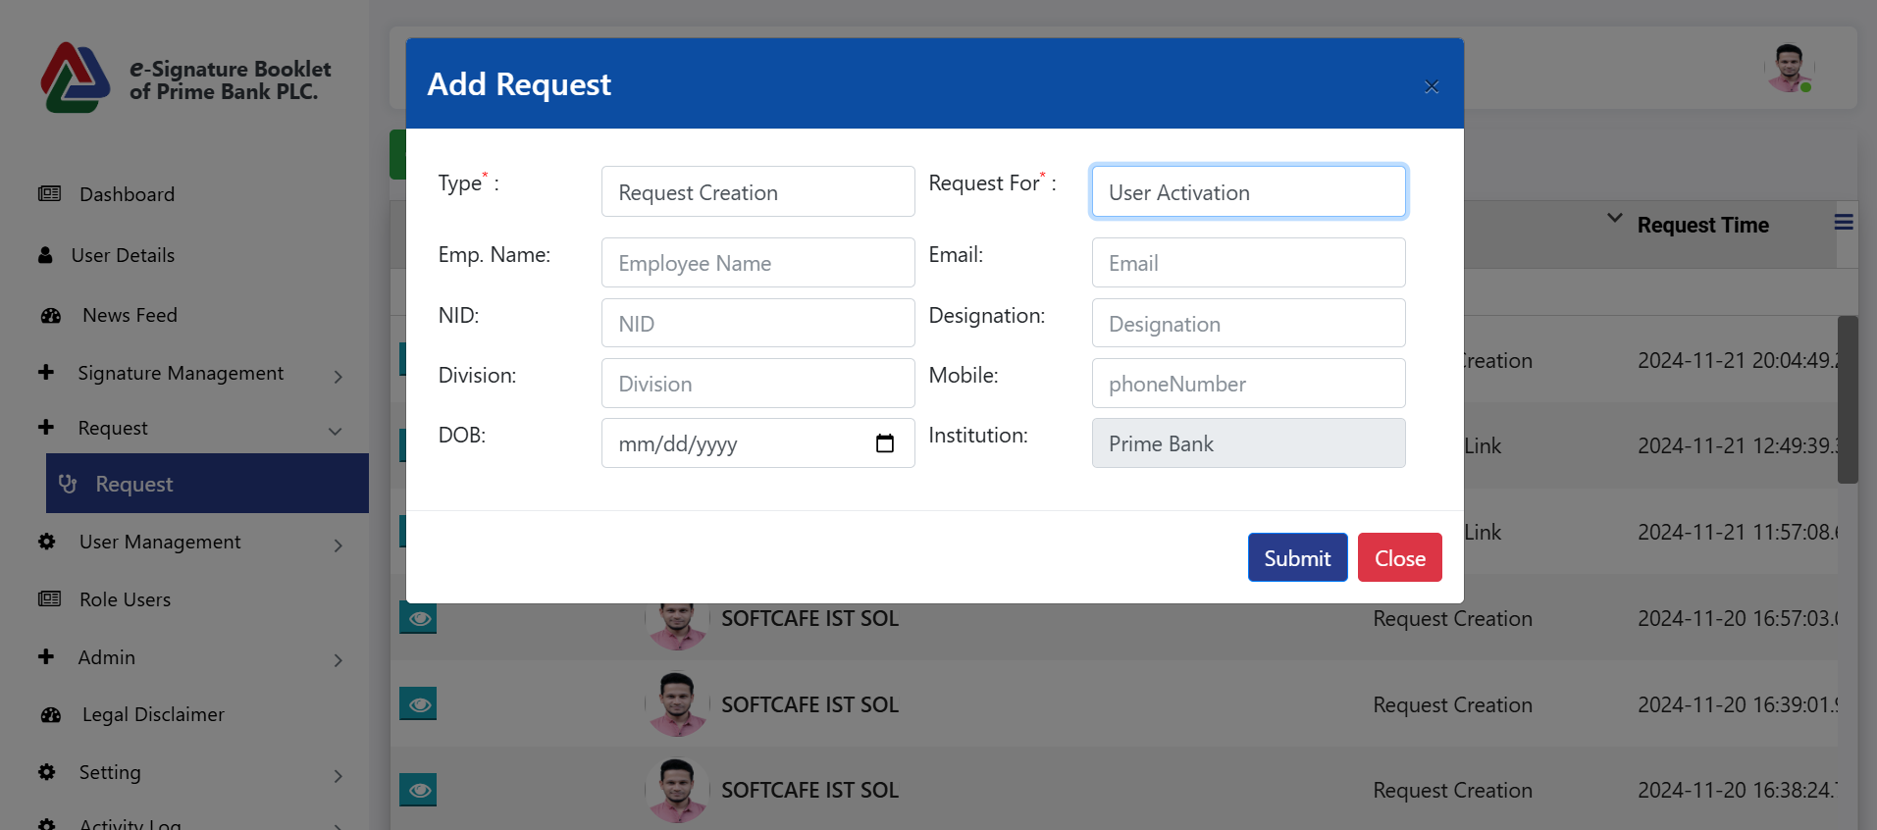

* Here, users can request activation of an account.

**Request for User De-Activation**

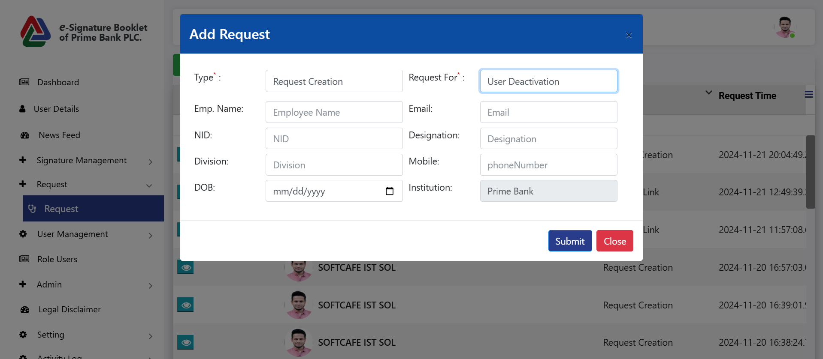

* Here, users can request de-activation of an account.

**Request For Service Request**

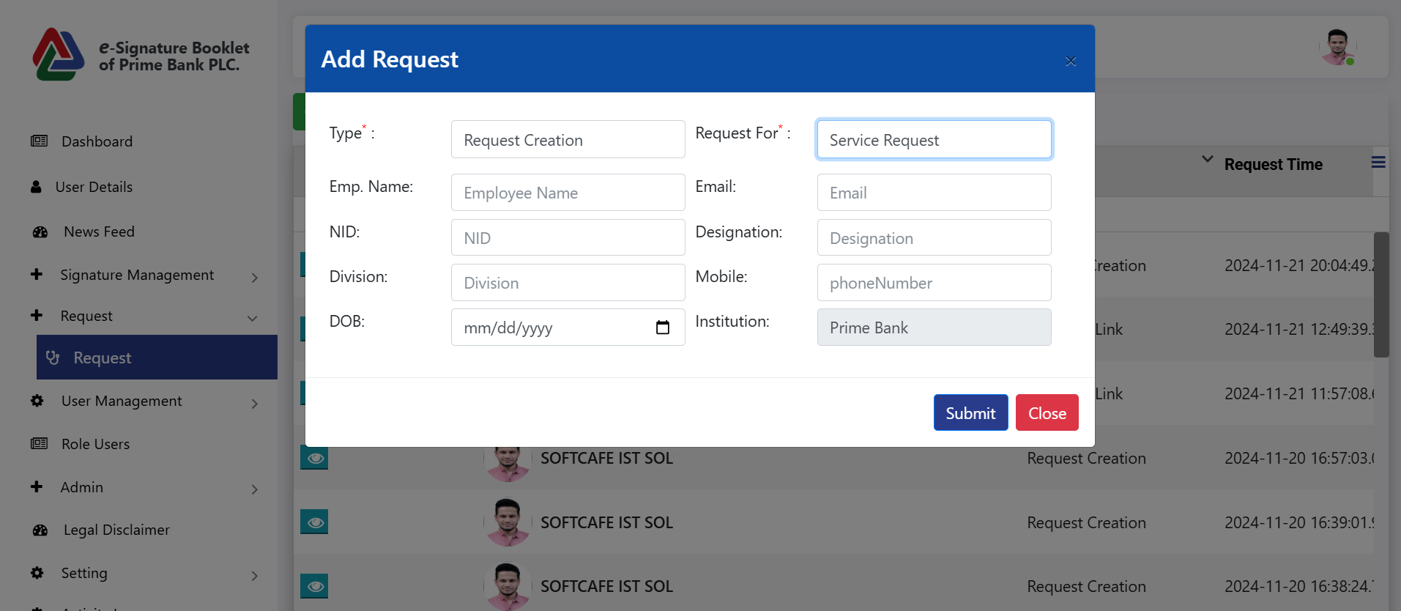

**Request for Generate Link**

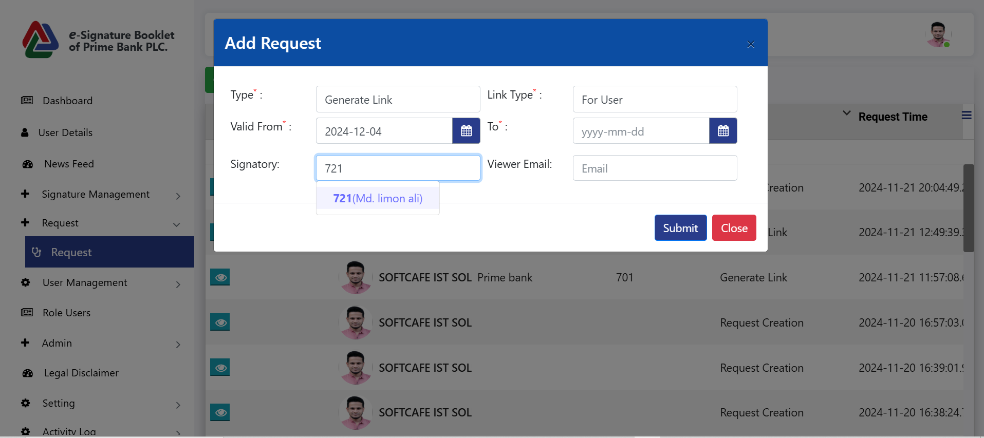

* Users can generate a link to view any signature for the list of users.

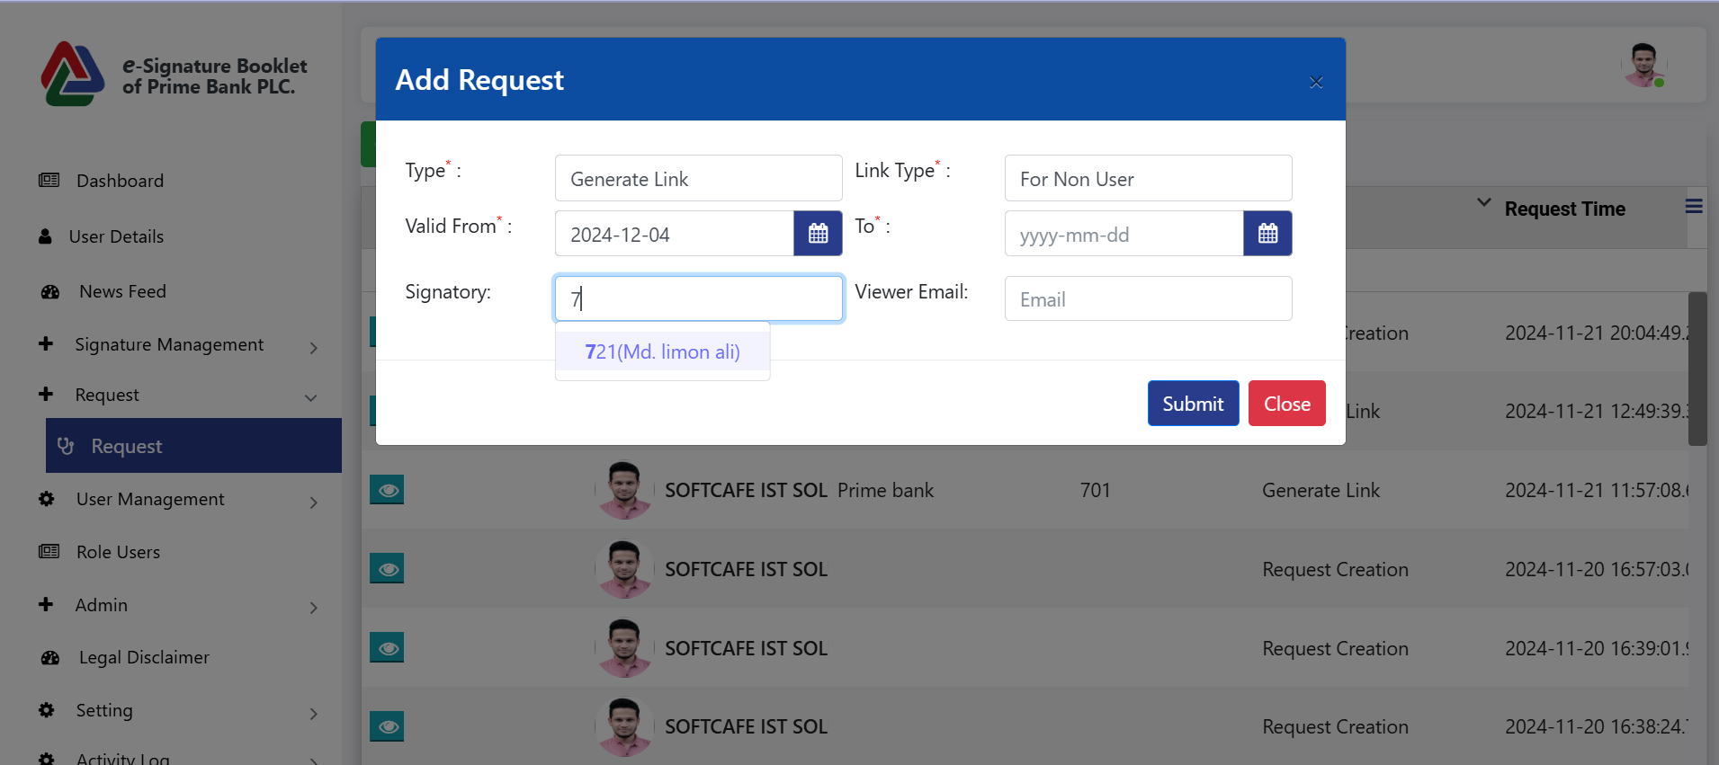

* Users can generate a link to view any signature for the list of non-users.

**Request for others**

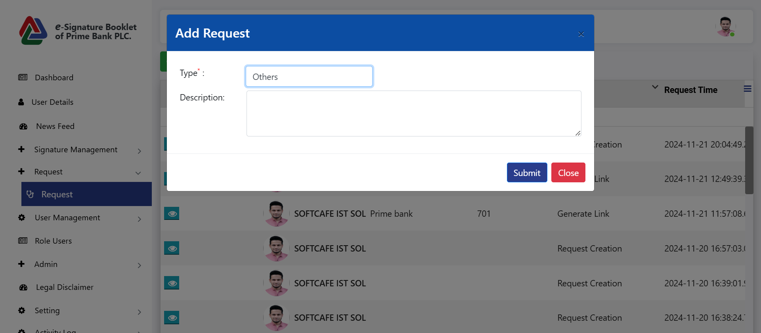

**Request list**

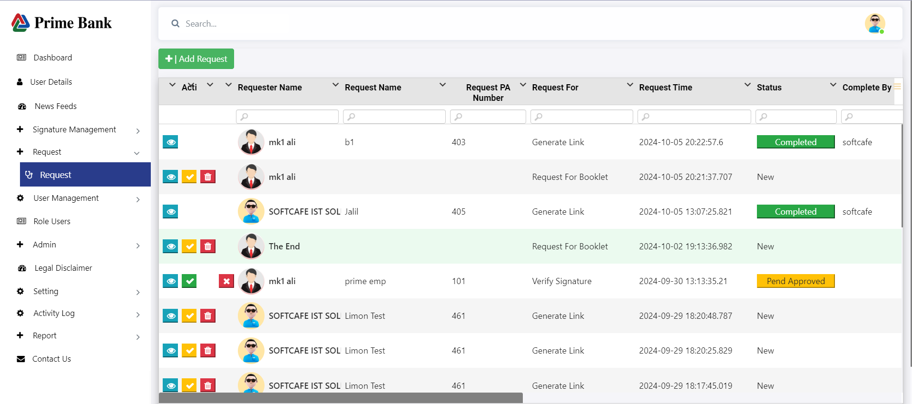

* Click on the view icon to display the request data.
* Click the yellow tick mark to approve the request.
* Click the green tick mark to authorize the request, and an email will be sent.
* Click the delete icon to delete the request.
* Click the cross icon to reject the request, and an email will be sent.)

**User Management :**

**User List:**

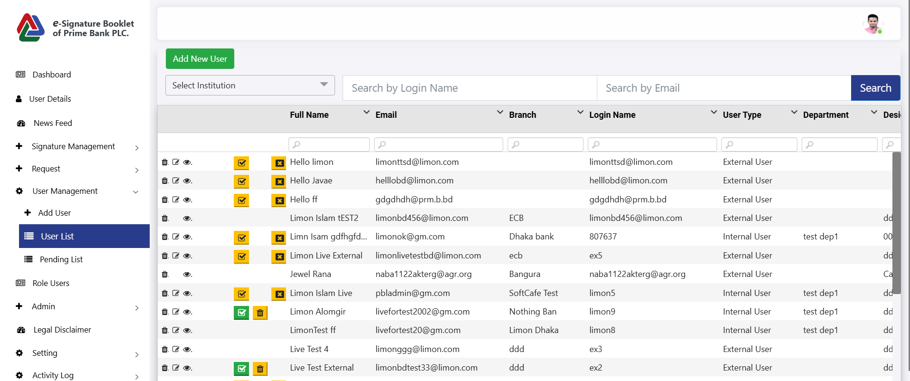

* **First, click the 'Admin' menu, then click the 'User List' menu to display all user data.**
* **Click the 'Add New User' button to open the User Information page.**
* **Click the delete icon to remove a user's information.**
* **Click the edit icon to update the user's information.**
* **Click the view icon to display all user information.**
* **Click the "Active/Inactive" button** to toggle between active and inactive status.
* After clicking, the change will **wait for approval.**
* **Click "Close"** to permanently delete the user.

**Add New User:**

**Internal User**

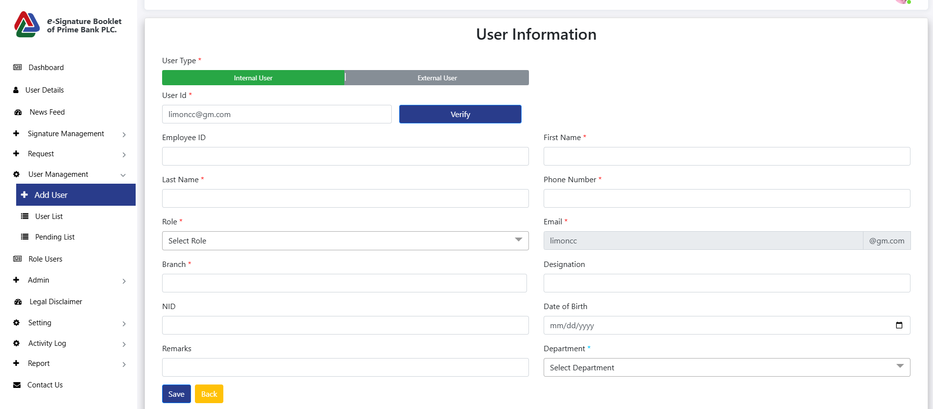

* **Click on the internal User type, then input the User ID.**
* **Click on the Verify button after showing the user details.**
* **All data must be entered before clicking the Save button.**

**External User**

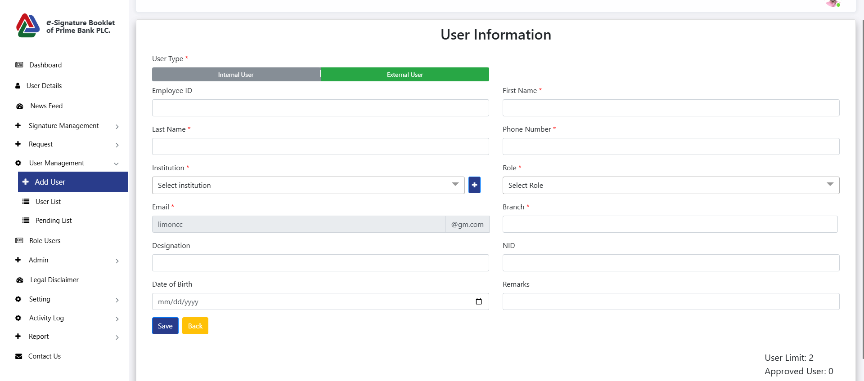

* Click on the "External User" type, then input data in all fields and click the "Save" button.

**Pending List:**

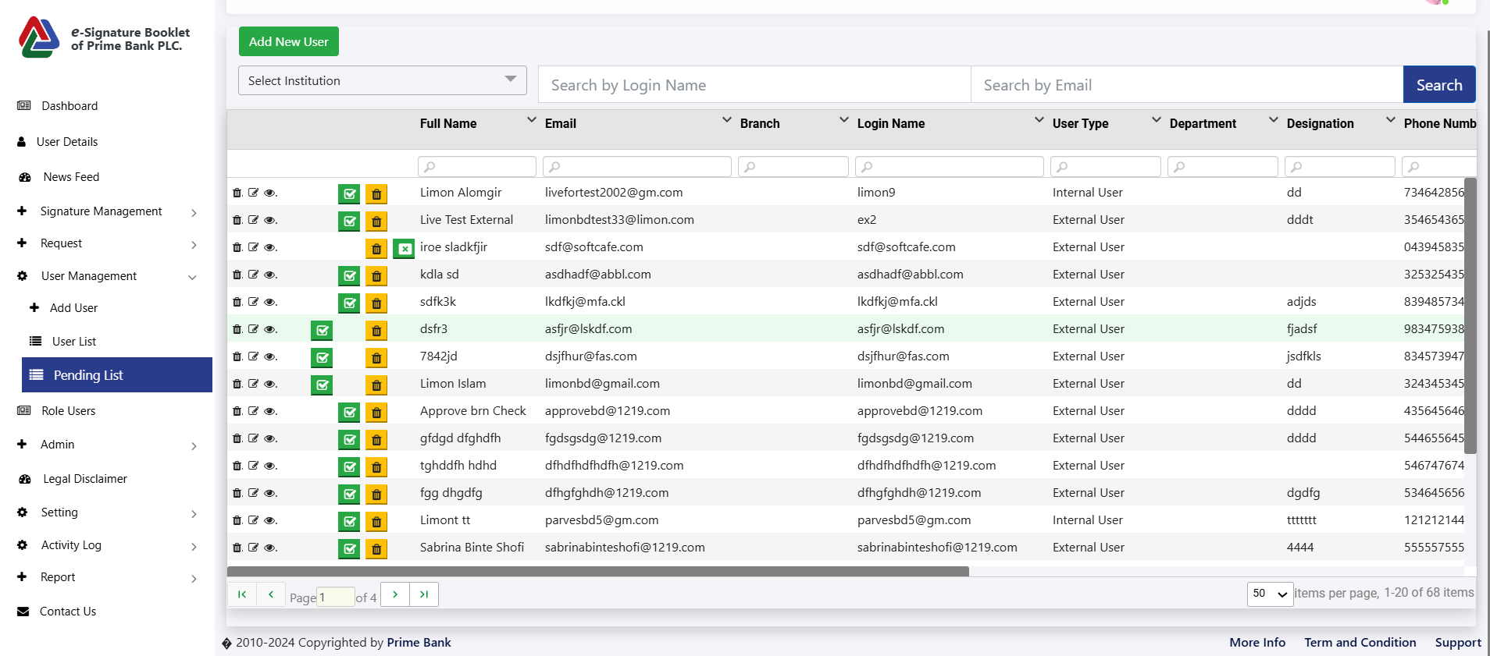

* **Click "Pending User List"** to show all **pending users.**

**Role Users:**

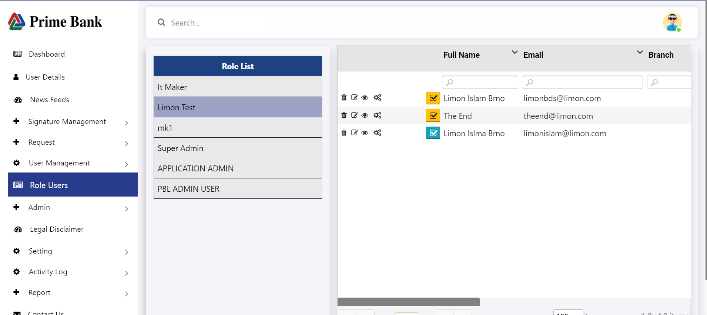

* First, click on 'Role Users' to display the role list. If you click on any role, all users under that role will be displayed

**Admin:**

**User List:**



* **First, click the 'Admin' menu, then click the 'User List' menu to display all user data.**
* **Click the 'Add New User' button to open the User Information page.**
* **Click the delete icon to remove a user's information.**
* **Click the edit icon to update the user's information.**
* **Click the view icon to display all user information.**
* **Click the "Active/Inactive" button** to toggle between active and inactive status.
* After clicking, the change will **wait for approval.**
* **Click "Close"** to permanently delete the user.

**Add New User:**

**Internal User**



* **Click on the internal User type, then input the User ID.**
* **Click on the Verify button after showing the user details.**
* **All data must be entered before clicking the Save button.**

**External User**



* Click on the "External User" type, then input data in all fields and click the "Save" button.

**Pending List:**



* **Click "Pending User List"** to show all **pending users.**

**Role:**

**Add Role**

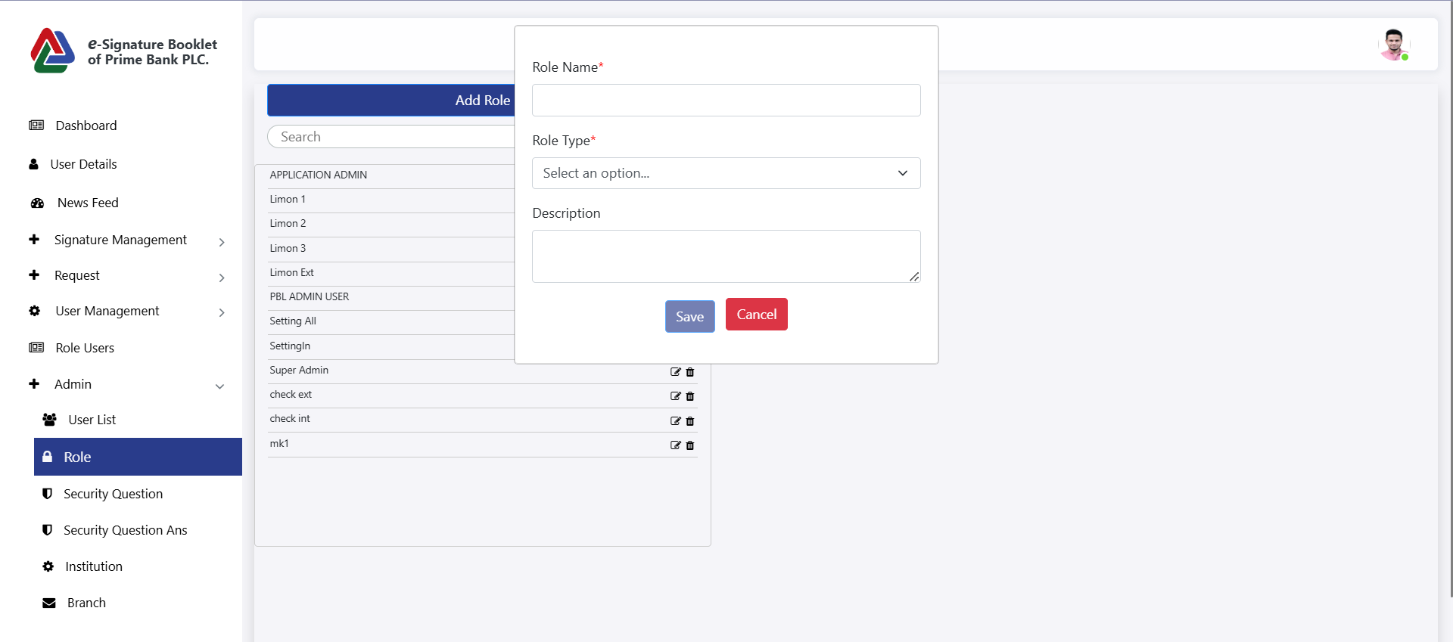

* Click on the Role menu then show the role.
* Click on the "Add Role" button. After the popup opens, enter the Role Name, Role Type and Description, then click the "Save" button.

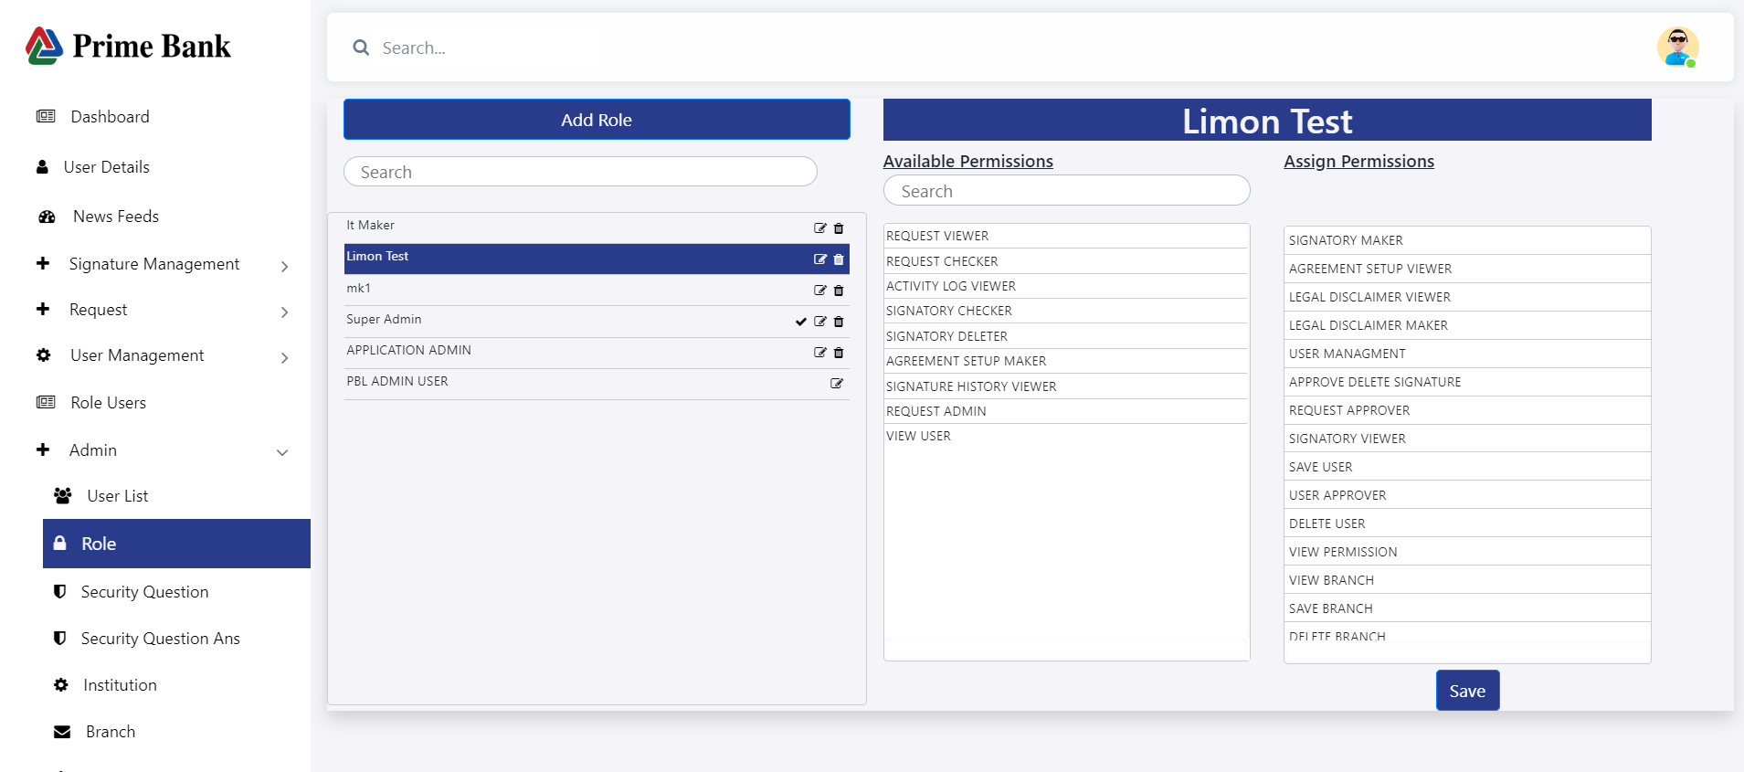

* Click any Role and Assign Permissions
* Click on the edit icon, then update Role.
* Click on the Delete icon, then delete Role.

**Security Question:**

**Add Question**

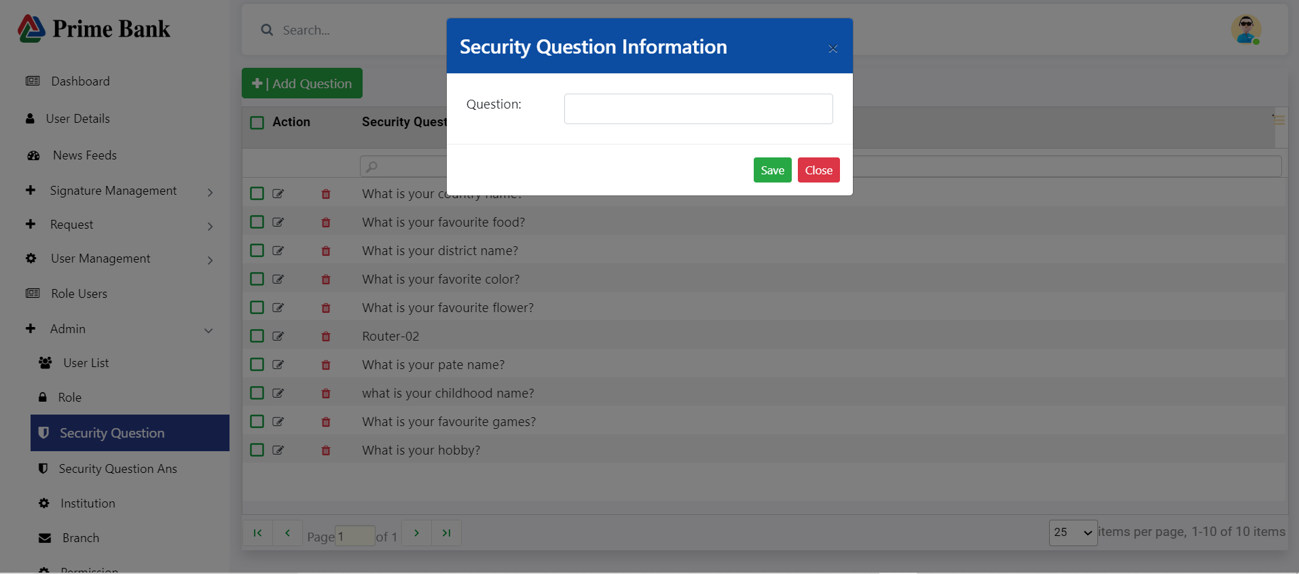

* Click on the Security Question menu, then click on the Add Question button, input the question field, and finally click on the Save button.

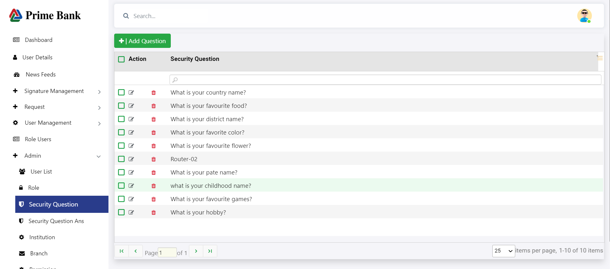

* Click on the edit icon, then update Question.
* Click on the Delete icon, then delete Question.

**Security Question Answer:**

**Add Question Answer**

* Click on the Security Question Answer menu, then click on the Add Question Answer button, Select the question field, input Answer, and finally click on the Save button.

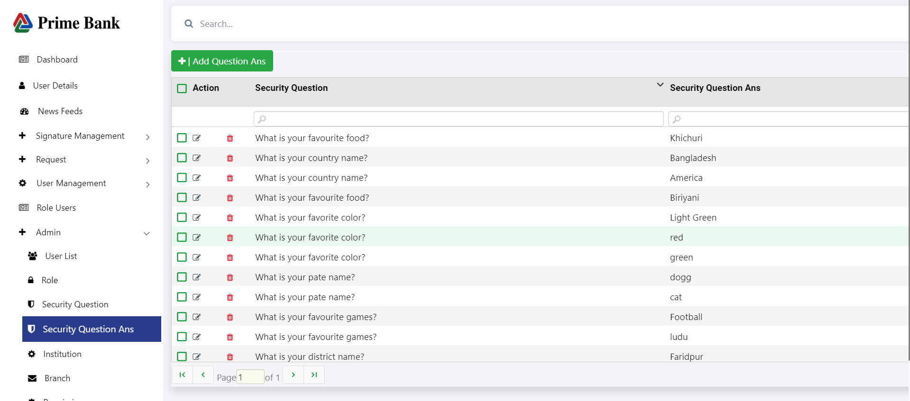

* Click on the edit icon, then update Question Answer.
* Click on the Delete icon, then delete Question Answer.

**Institution:**

**Add Institution**

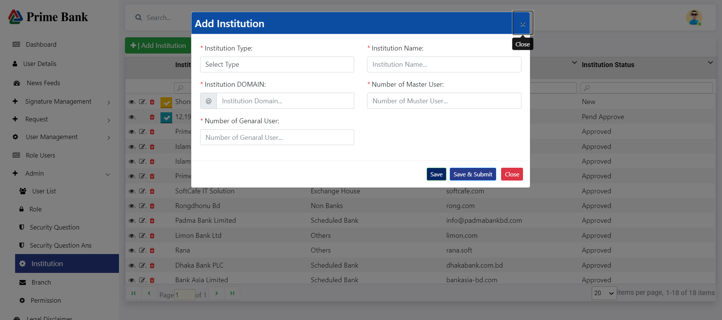

* First, click the 'Institution' menu, then click the 'Add Institution' button to open the popup. Input all fields, and finally, click the 'Save' button.
* Click the 'Save & Submit' button to save all data and authorize another person.

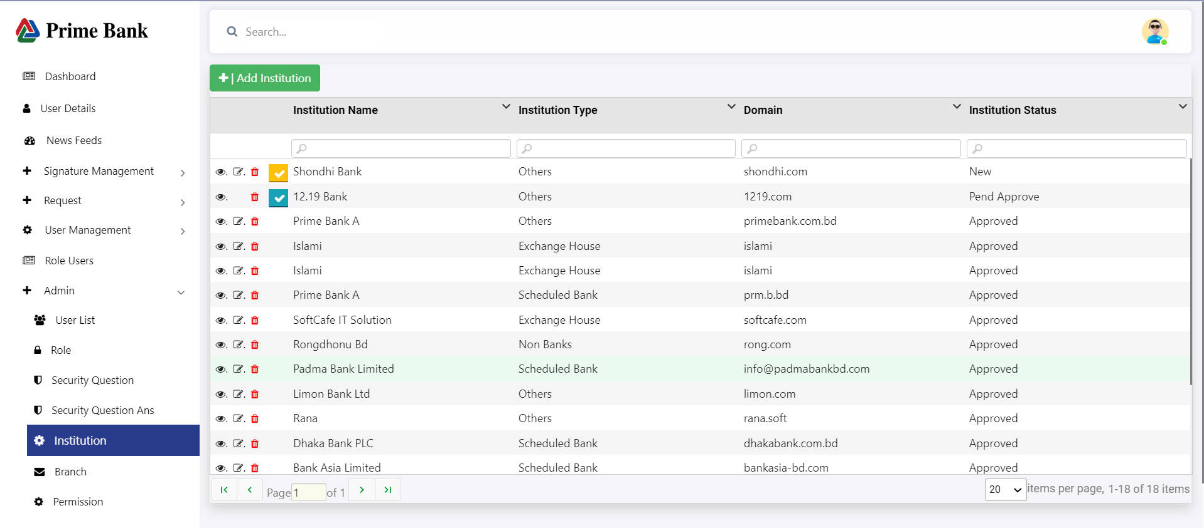

* Click on the 'Institution' menu to show the list of all institutions.
* Click on the view icon to show single institution data.
* Click on the edit icon to update the institution data.
* Click on the delete icon, then delete the single institution.
* Click on the check mark, then authorize the institution.

**Branch:**

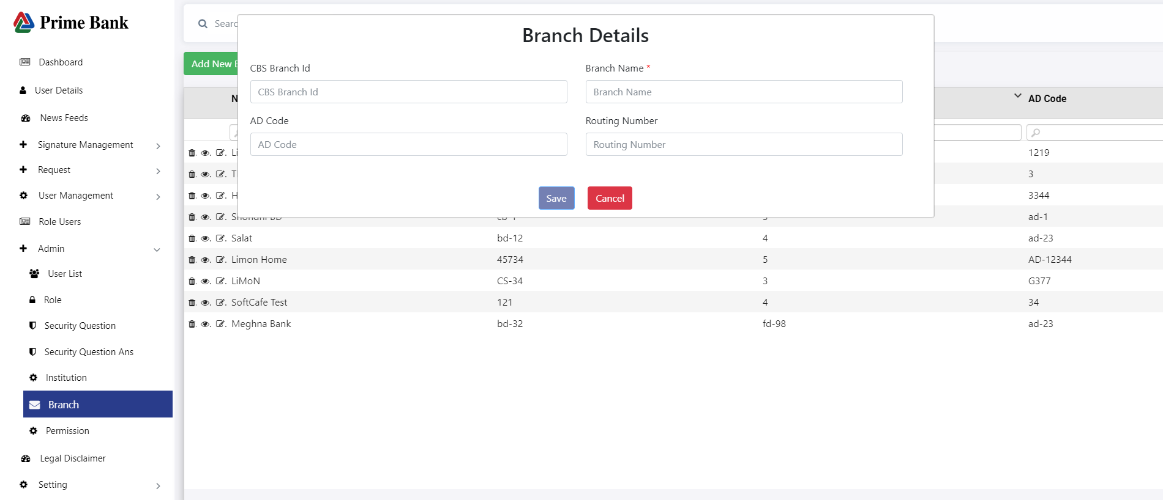

* First, click the Branch menu, then click on the 'Add New Branch' button to open the Branch Details page.
* Do input data in all fields and then click the Save button.

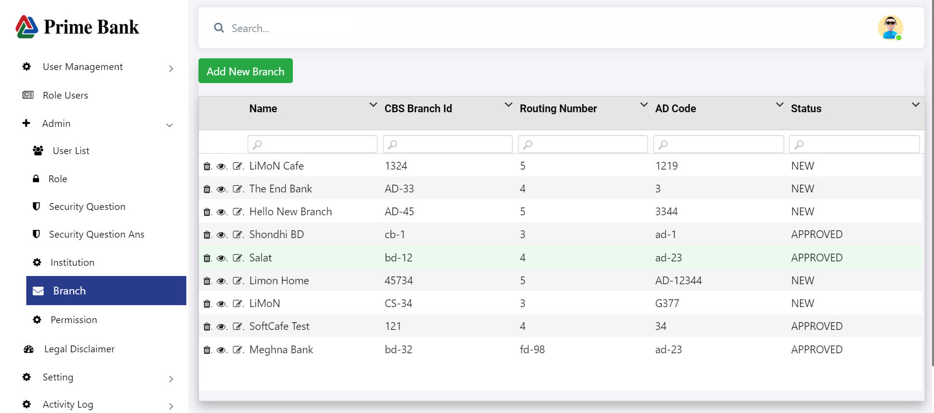

* Click on the Branch menu to display the Branch data.
* Click on the delete icon, then delete single branch data.
* Click on the view icon to show single branch data, then click on the approved button.
* Click on the edit icon to update the branch data.

**Permission:**

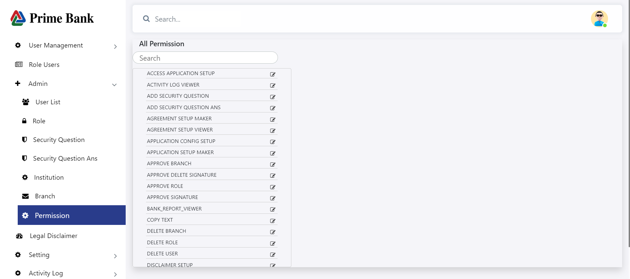

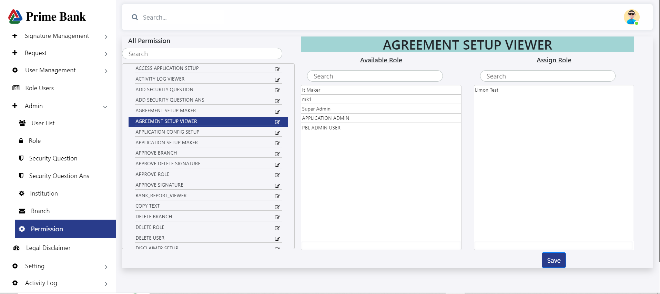

* User can drag & drop role (available role to assign role), Approve Role has permission to access save button.
* Each user is granted permissions separately

**Legal Disclaimer:**

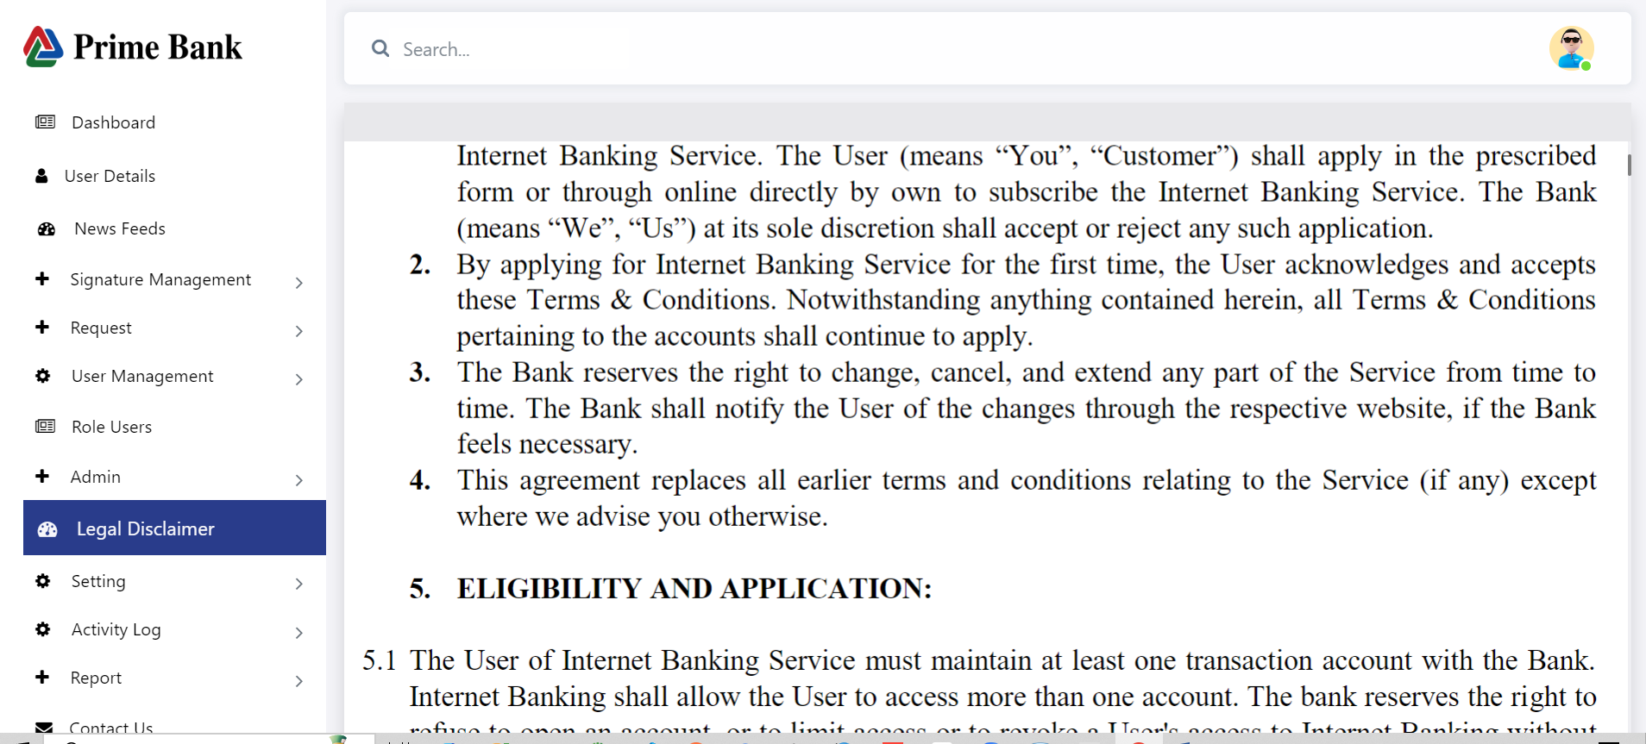

**Setting**

**Application Config:**

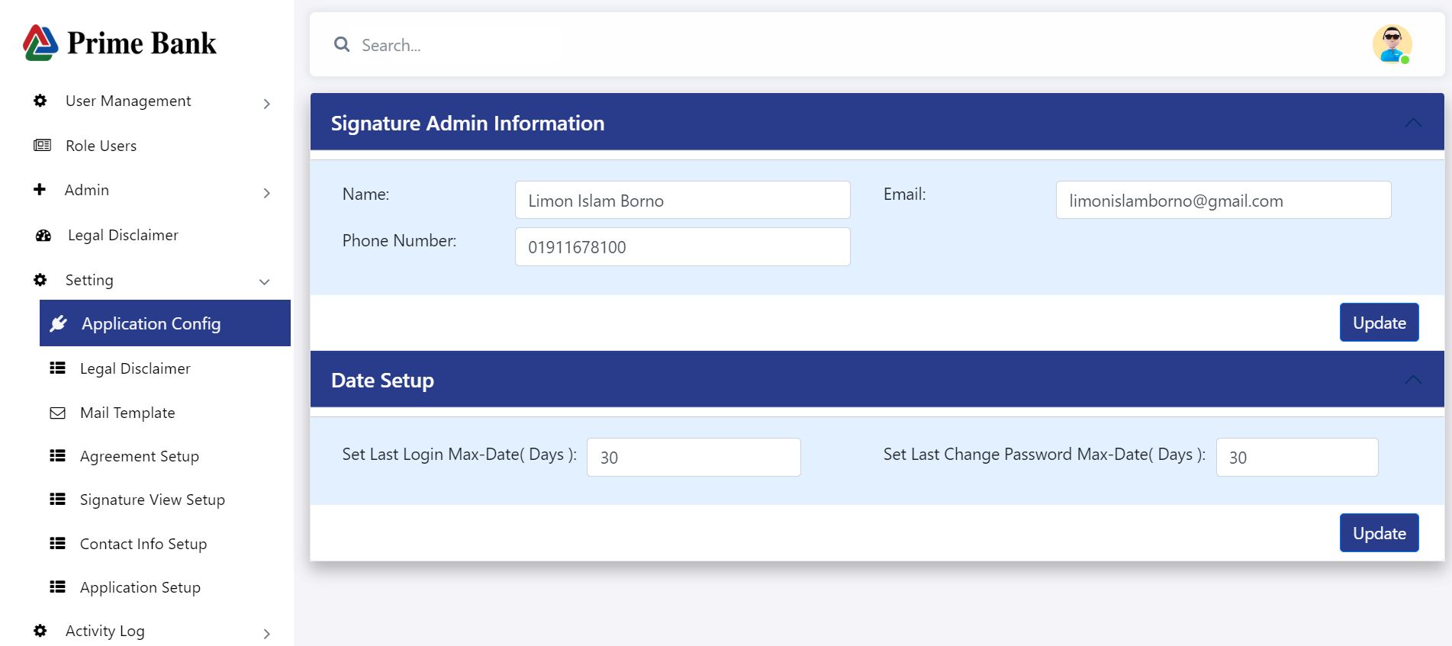

* Users can dynamically set the signature admin information, last login max date, and last password change max date.

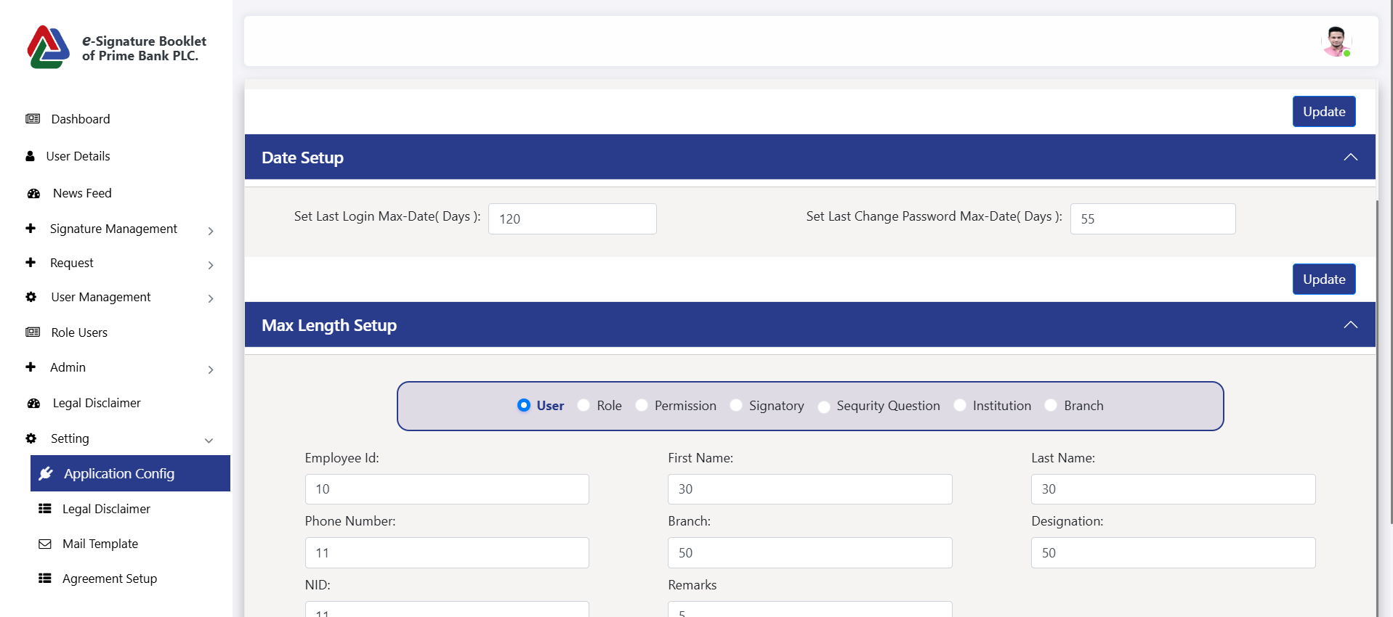

* **Users can dynamically control the maximum input length** for all form fields in the application.

**Legal Disclaimer**

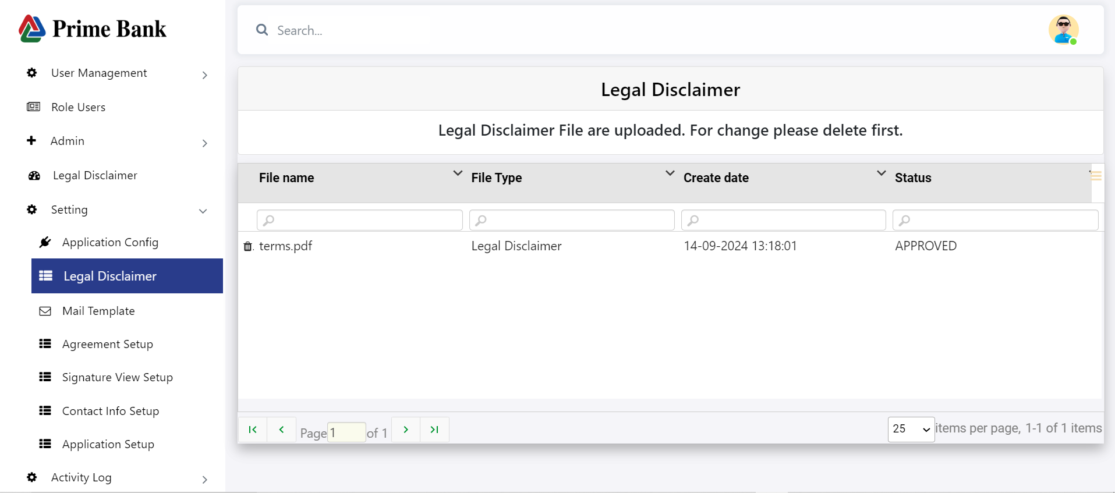

* Click the delete icon to remove the legal disclaimer. If deleted, the option to add a new one will be displayed

**Mail Template:**

**Add New Mail Template:**

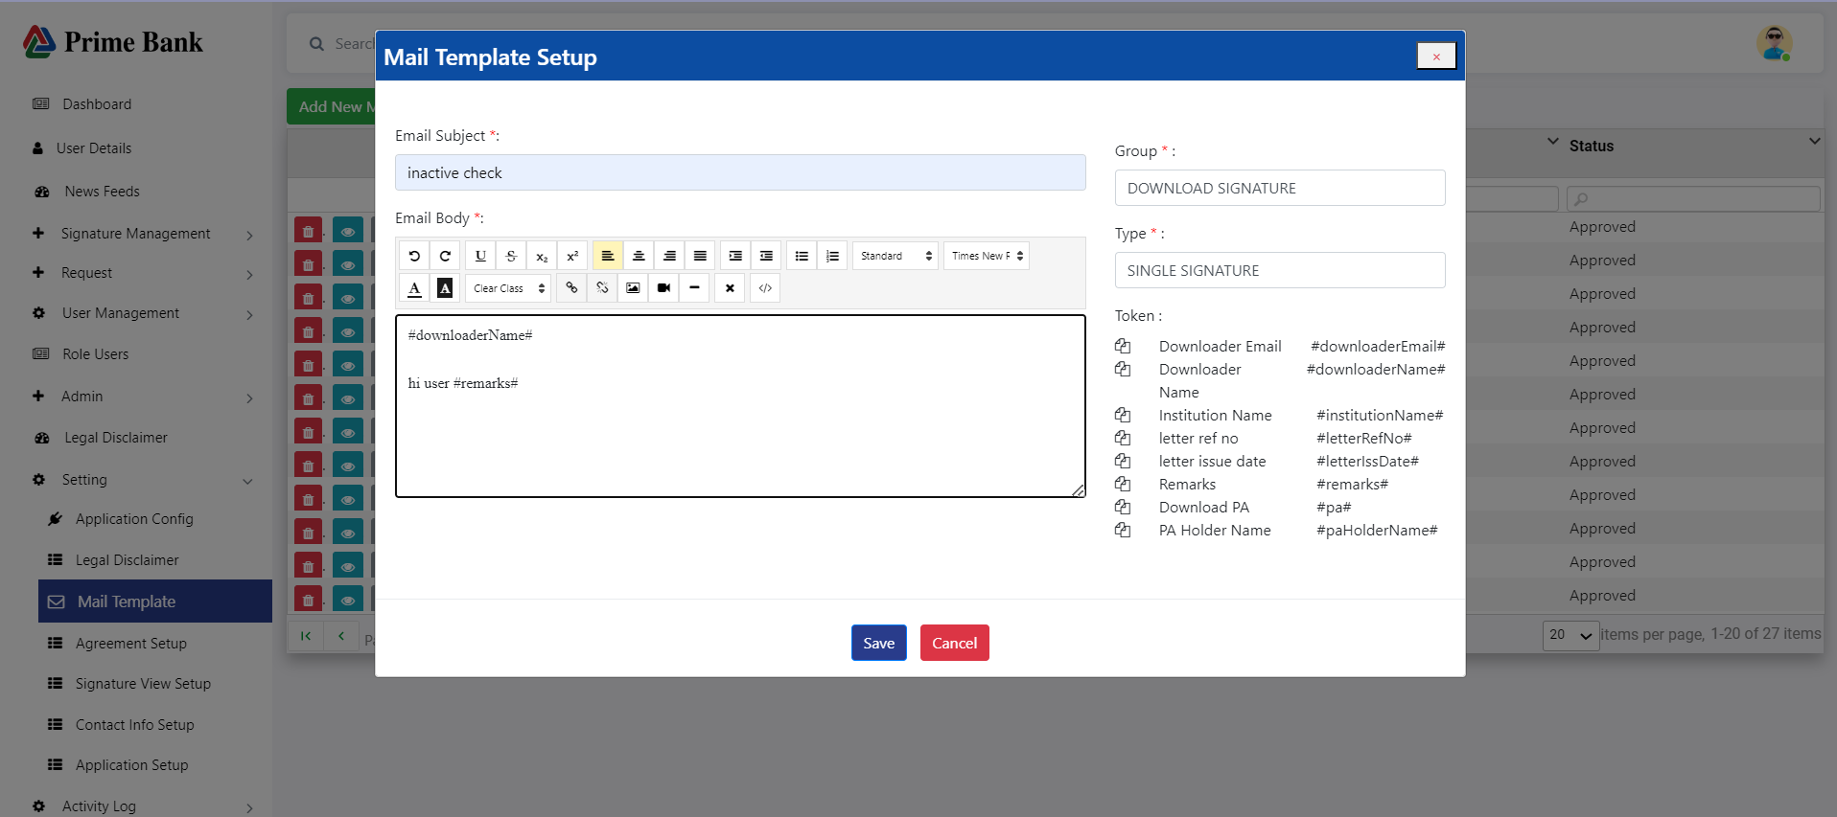

* Click 'Add New Mail Template' to add a new template

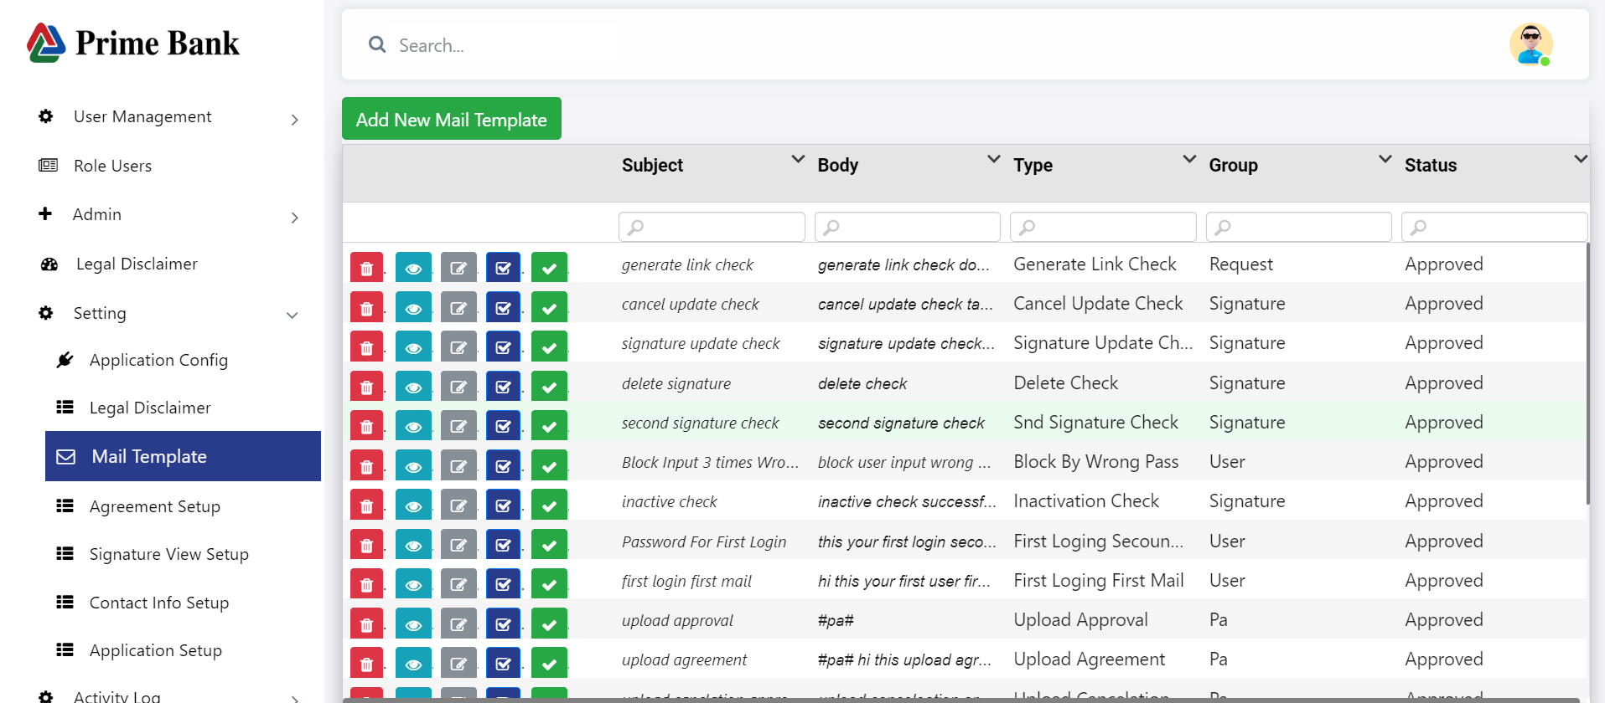

* Click on the 'Mail Template' menu to display the mail template data.
* Click the delete icon to remove a single mail template.
* Click the view icon to show a single mail template, then click the 'Approve' button.
* Click the edit icon to update the mail template.

**Agreement Setup:**

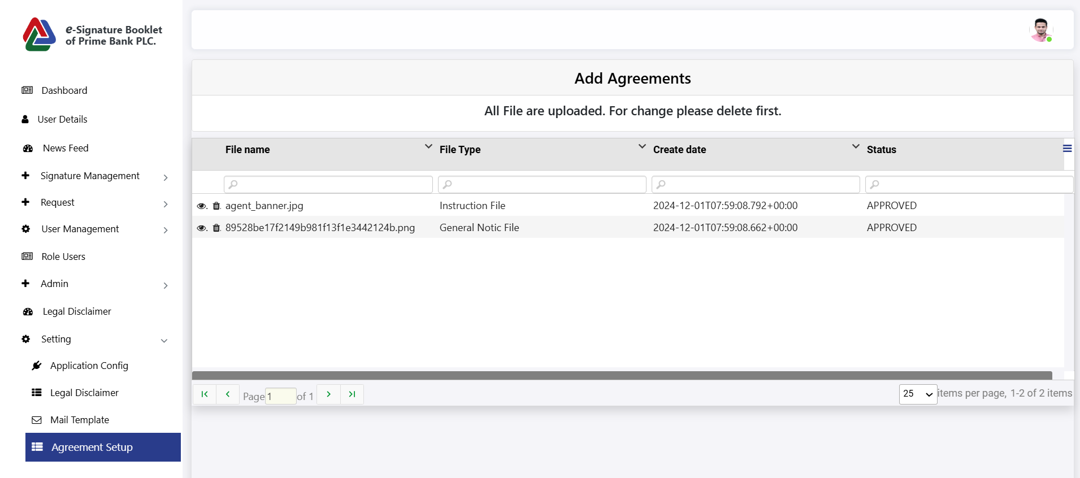

* Click the delete icon, and the agreement file will be deleted. Then an option to upload another file will appear.

**Signature View Setup :**

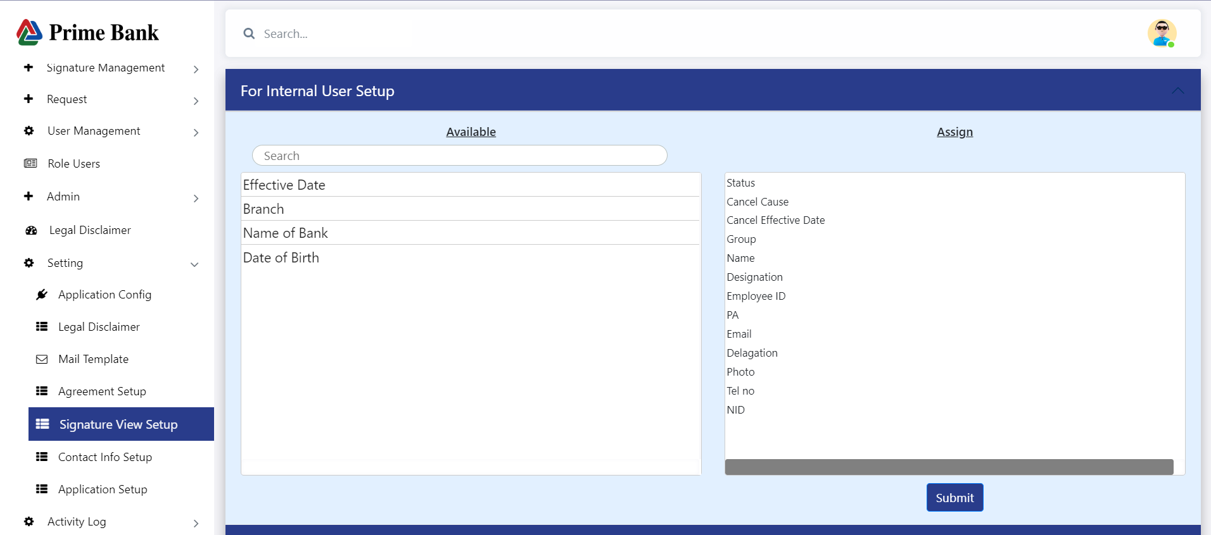

* First, click 'Signature View Setup,' then drag and drop the fields you want to display in the signature view. Here are two options: **Internal** and **External** individuals.

**Contact Info Setup:**

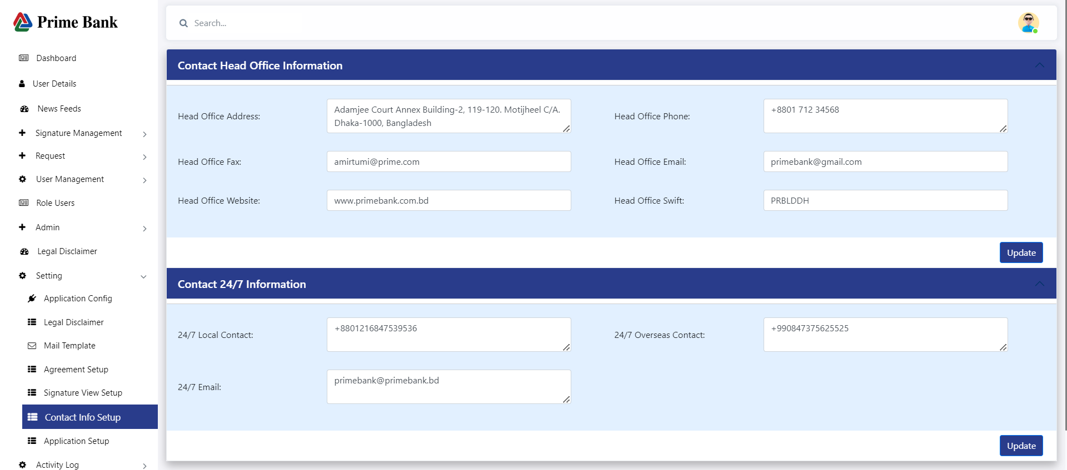

* Click the update button to update all contact information.

**Application Setup**

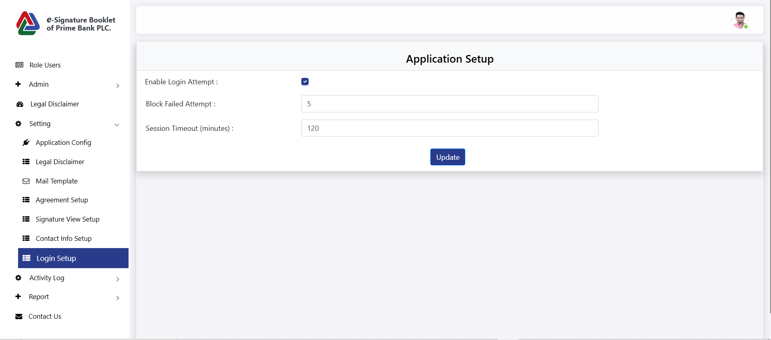

* Click update to change the application setup.

**Activity Log**

**Logs :**

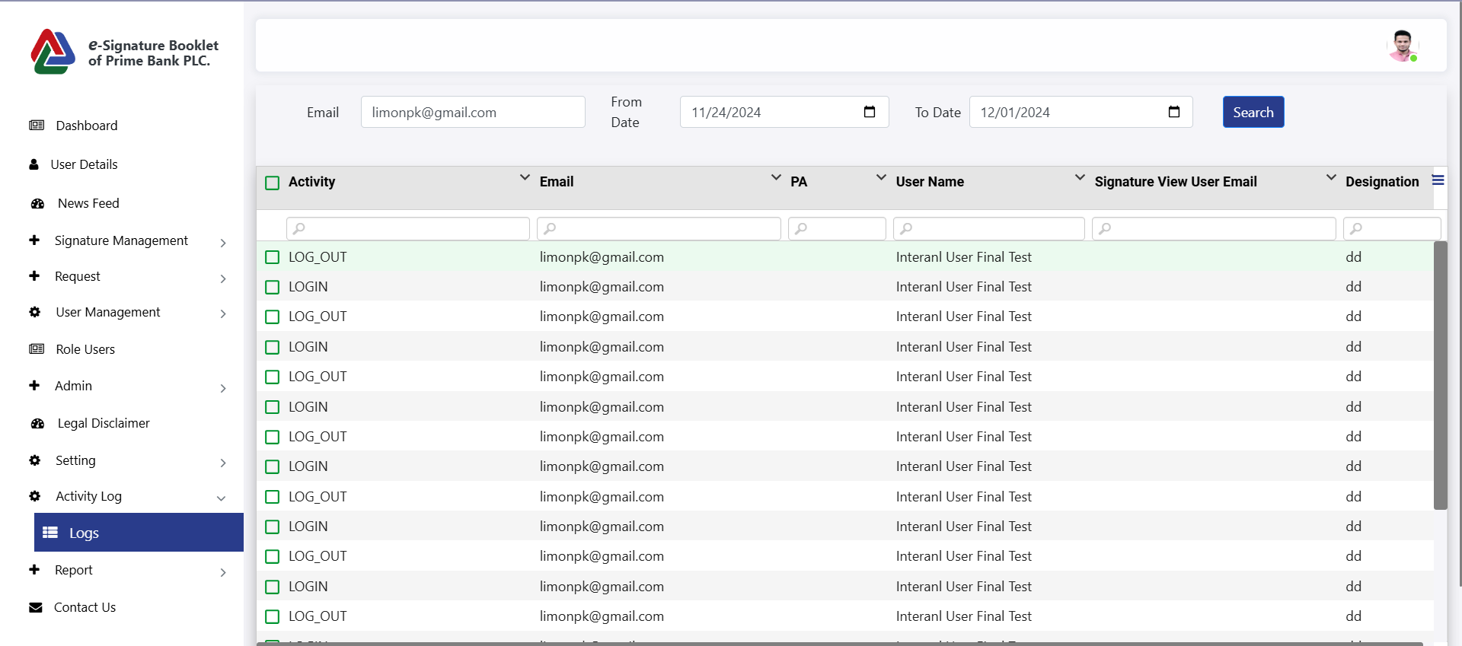

* Click on "Activity Logs," then select "Logs" to display all available activity logs.

**Report:**

**Logged Report :**

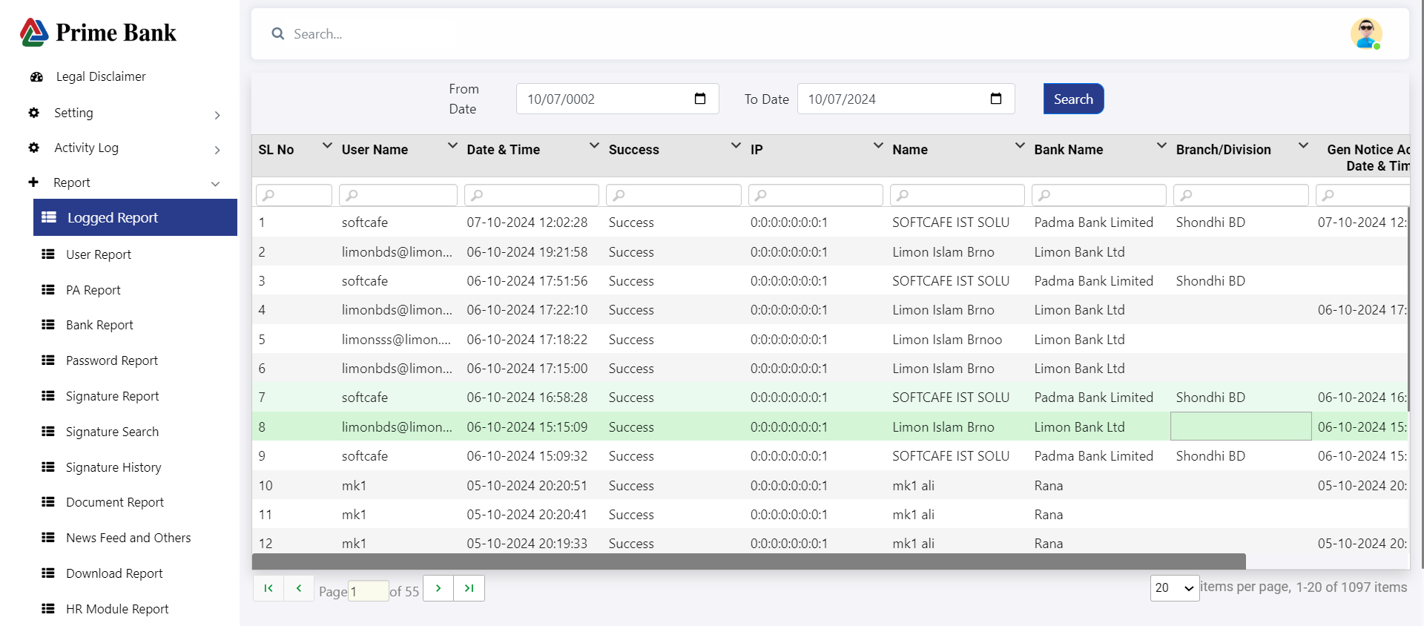

* Click "Report," then the submenu "Logged Report" to show all logged reports.
* Input "From Date" and "To Date" to filter logged reports by a date range

**User Report :**

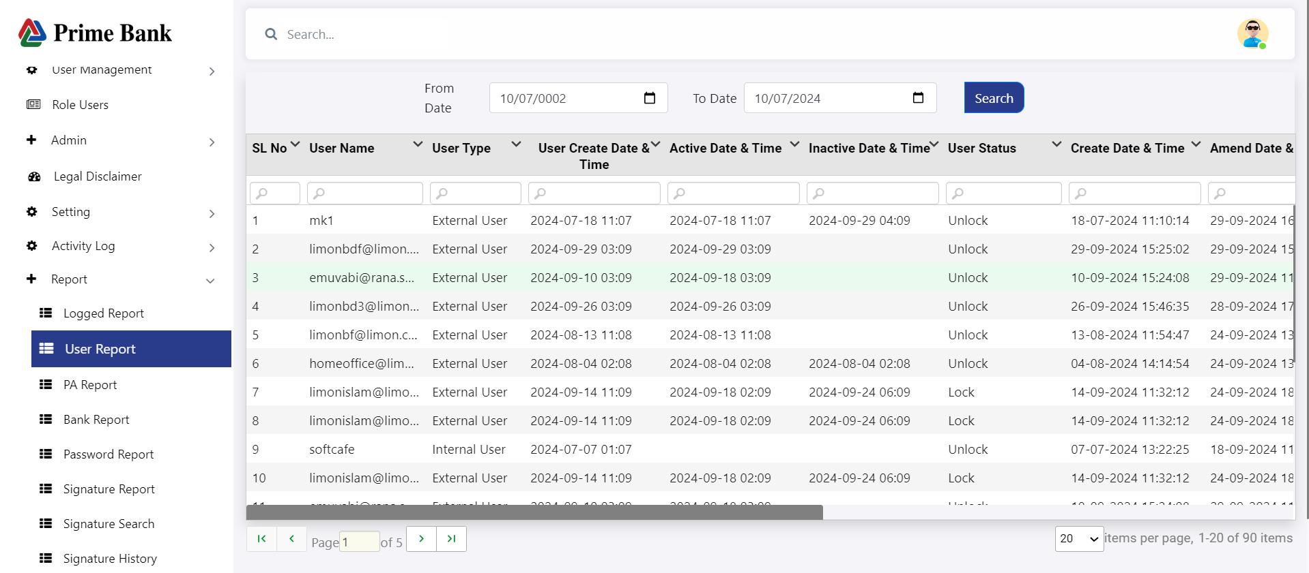

* Click "Report," then the submenu "User Report" to show all user reports.
* Input "From Date" and "To Date" to filter user reports by a date range.

**PA Report :**

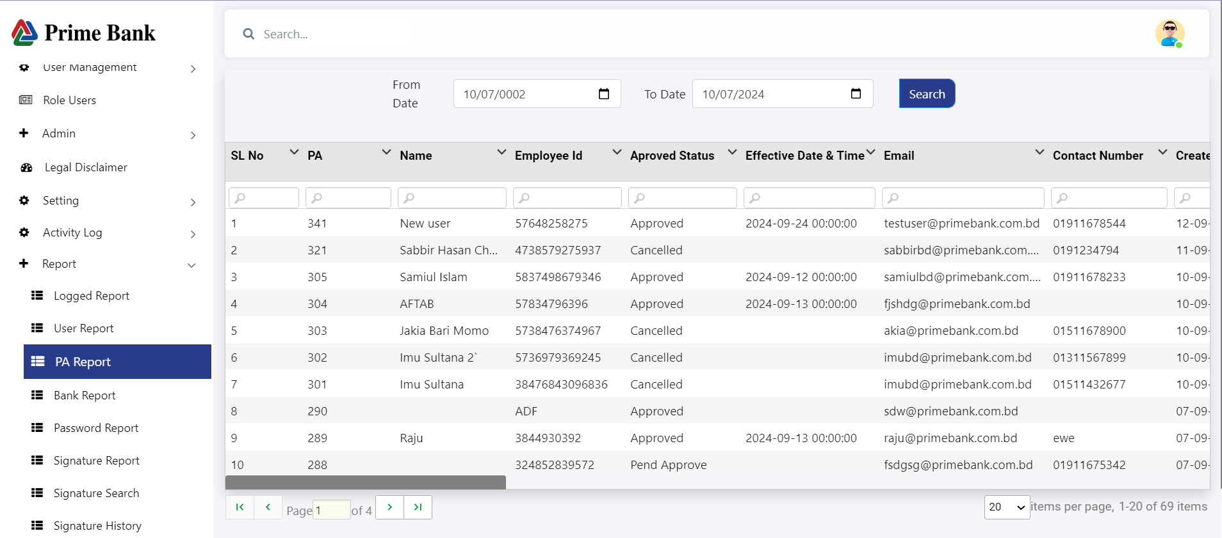

**PA Report :**



* Click "Report," then the submenu "PA Report" to show all PA reports.
* Input "From Date" and "To Date" to filter PA reports by a date range.

**Bank Report :**

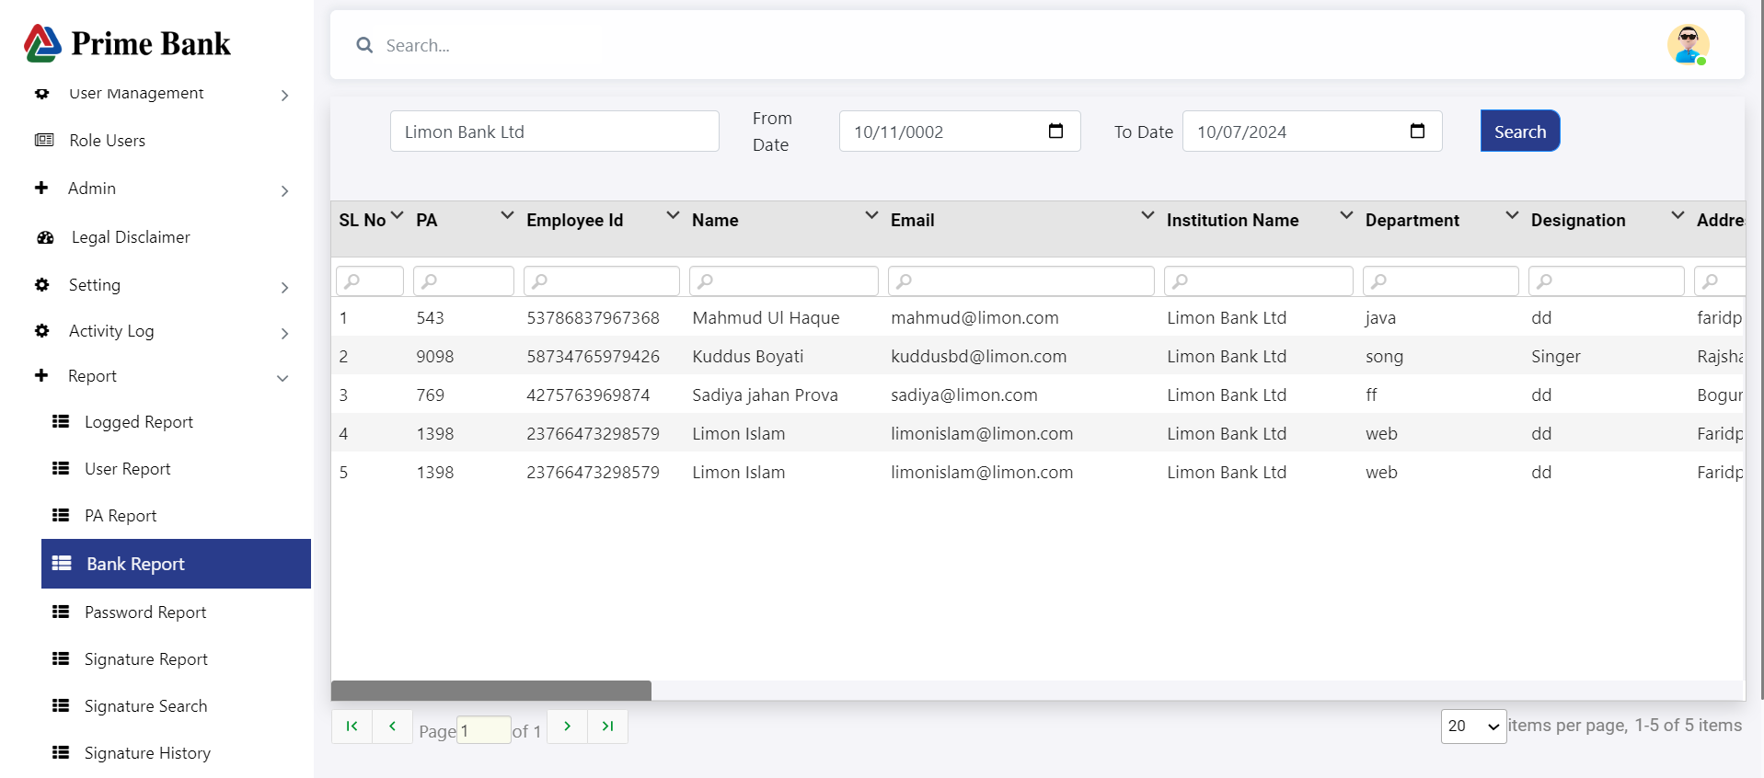

* Click "Report," then the submenu "Bank Report" to show all bank reports.
* Input "From Date" and "To Date" to filter bank reports by a date range, and also filter by institution name.

**Password Report :**

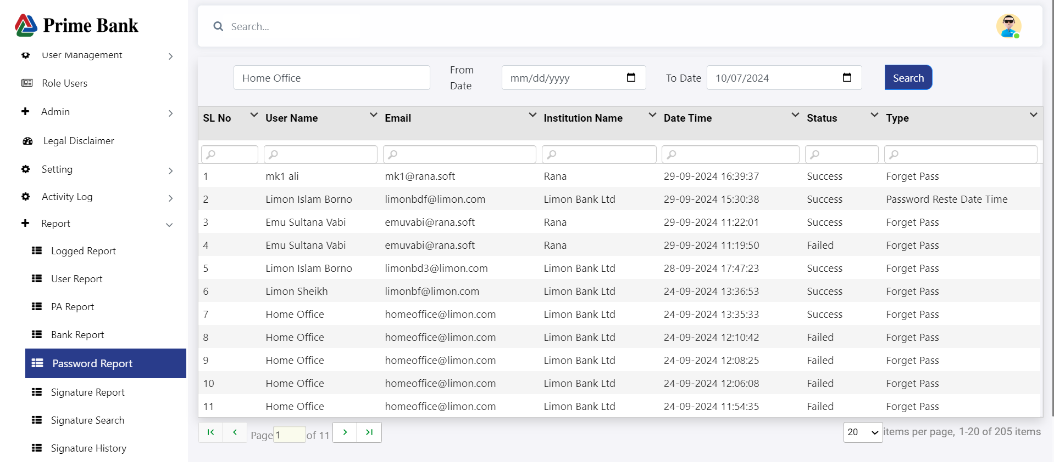

* Click "Report," then the submenu "Password Report" to show all password reports.
* Input "From Date" and "To Date" to filter password reports by a date range, and also filter by user name.

**Singnature Report :**

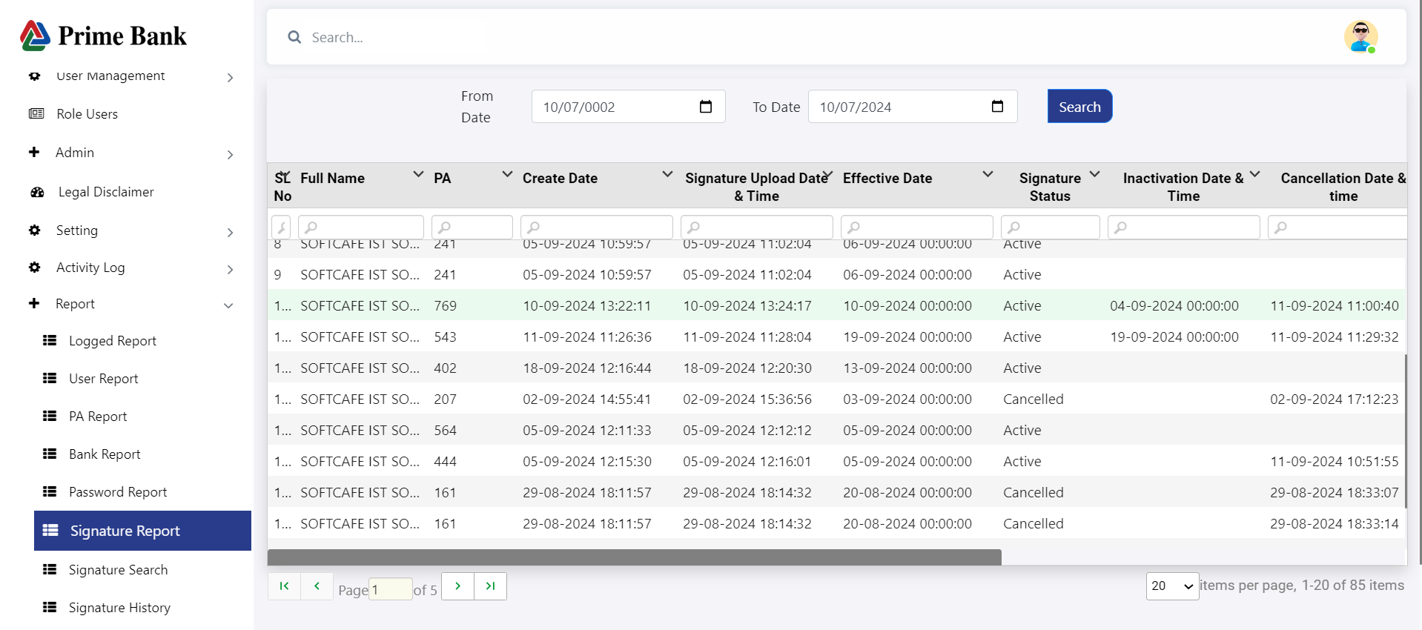

* Click "Report," then the submenu "Signature Report" to show all signature reports.
* Input "From Date" and "To Date" to filter signature reports by a date range.

**Signature Search Report :**

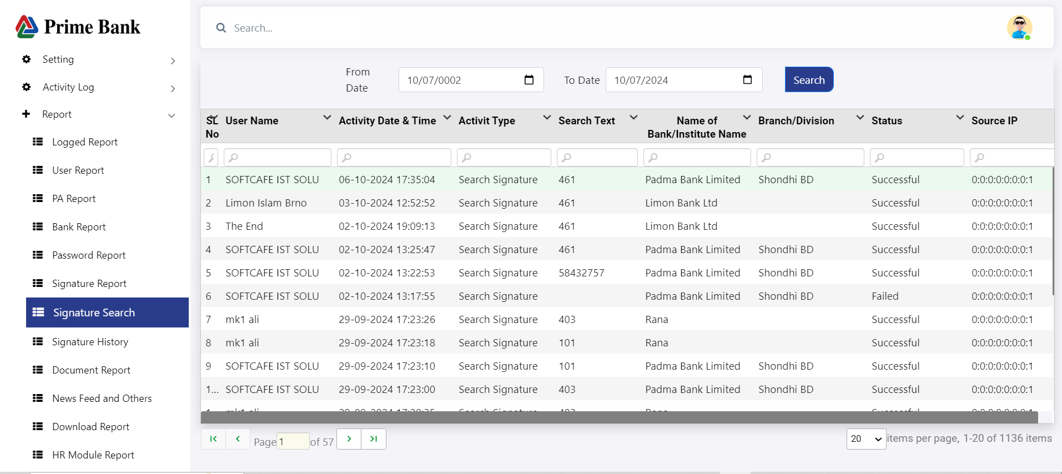

* Click "Report," then the submenu "Signature Search Report" to show all signature search reports.
* Input "From Date" and "To Date" to filter signature search reports by a date range.

**Signature History Report :**

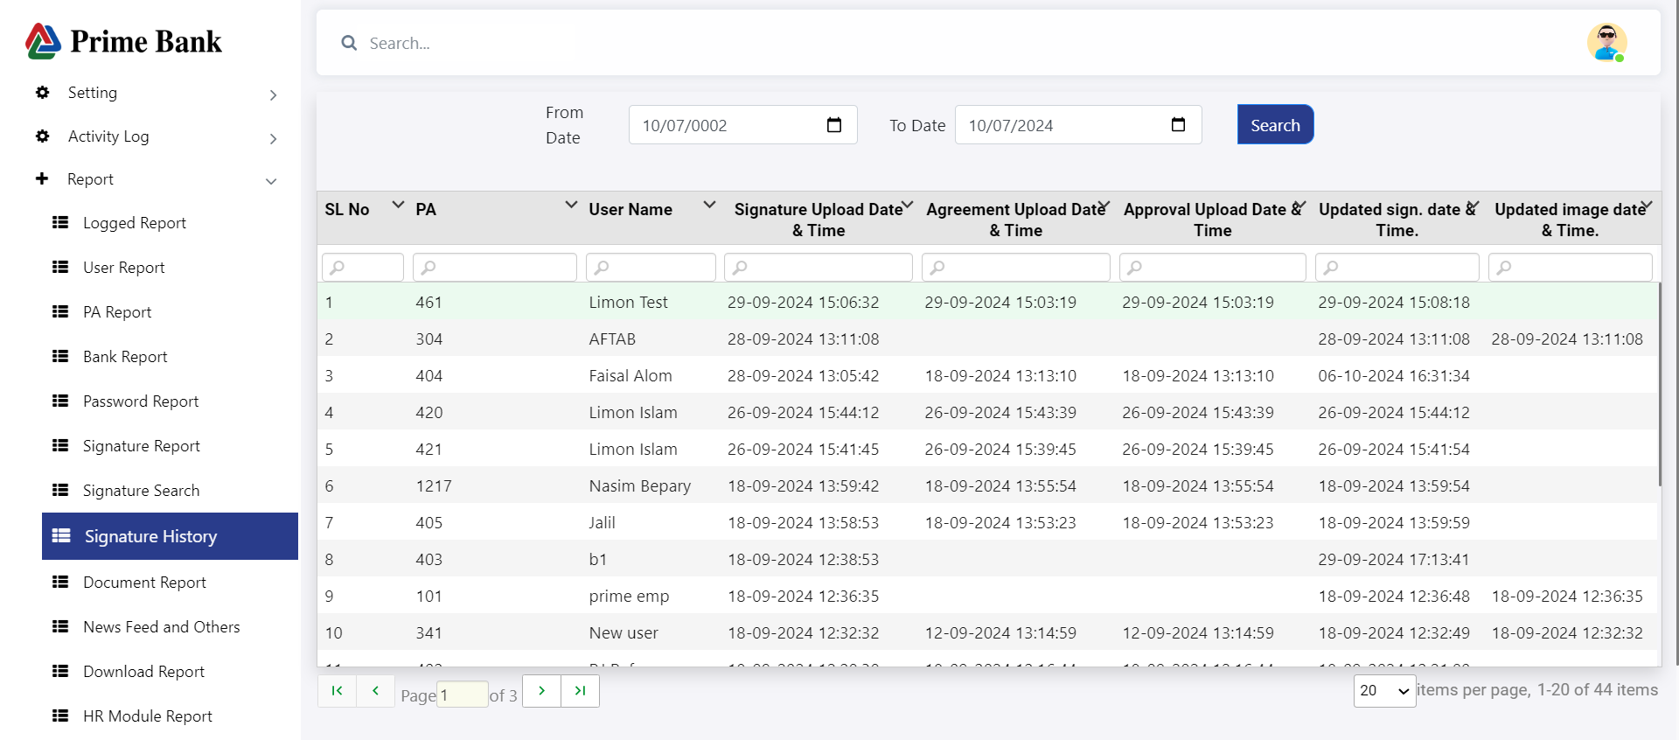

* Click "Report," then the submenu "Signature History Report" to show all signature history reports.
* Input "From Date" and "To Date" to filter signature history reports by a date range.

**Document Report :**

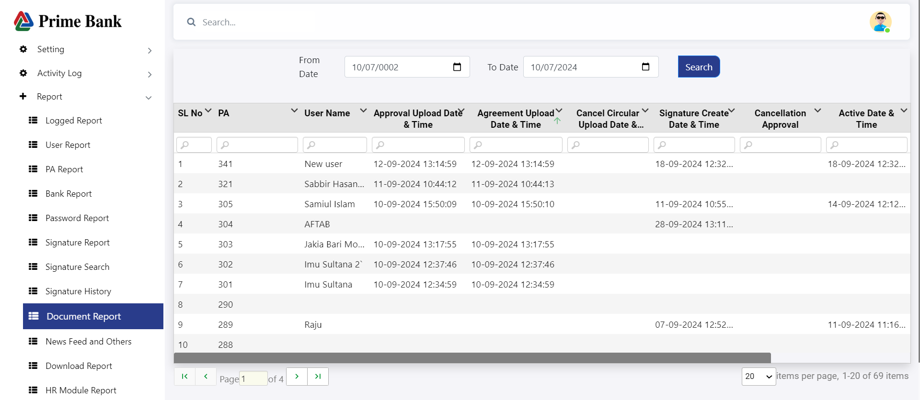

* Click "Report," then the submenu "Document Report" to show all document reports.
* Input "From Date" and "To Date" to filter document reports by a date range.

**HR Module Report :**

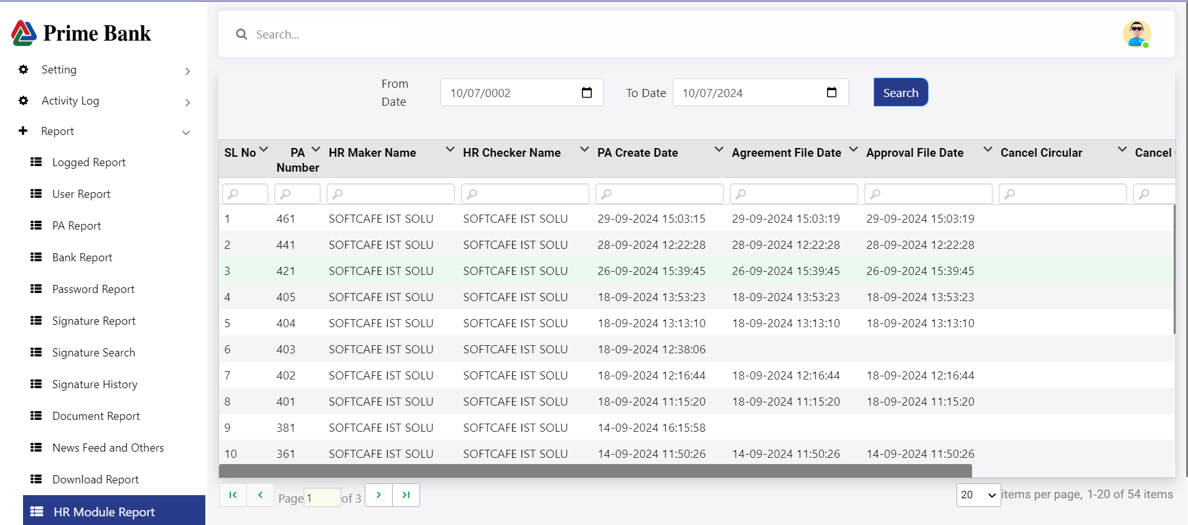

* Click "Report," then the submenu "HR Module Report" to show all HR module reports.
* Input "From Date" and "To Date" to filter HR module reports by a date range.

**Exception Report :**

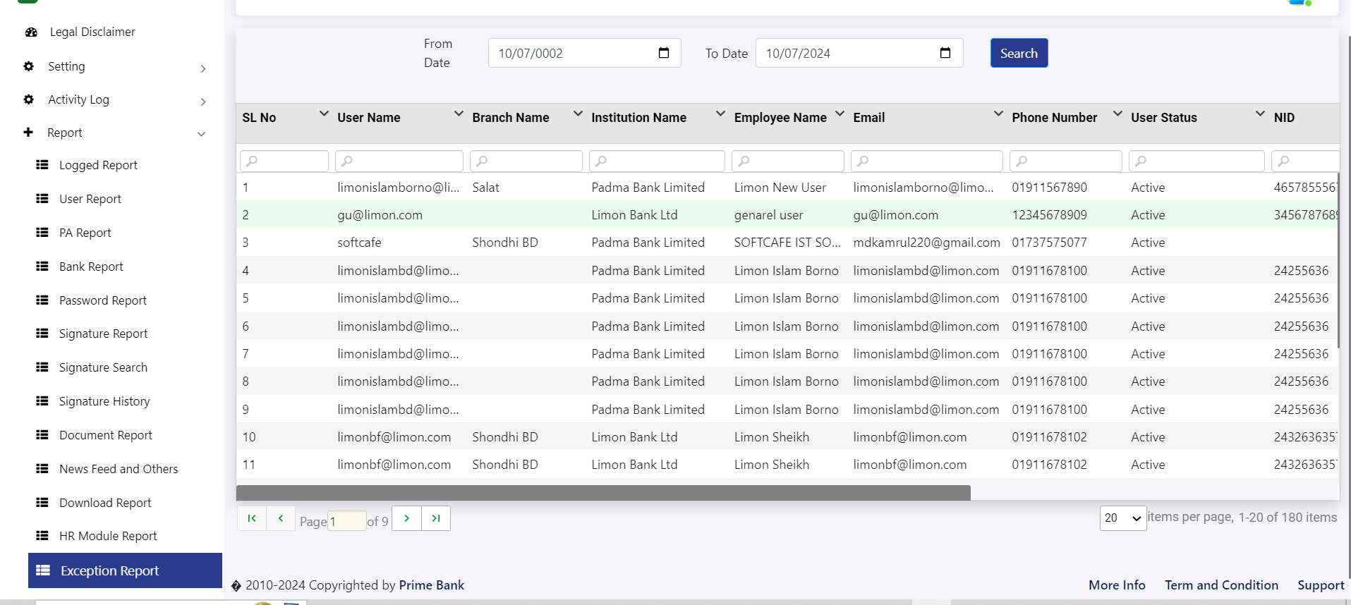

* Click "Report," then the submenu "Exception Report" to show all exception reports.
* Input "From Date" and "To Date" to filter exception reports by a date range.

**User Audit Report :**

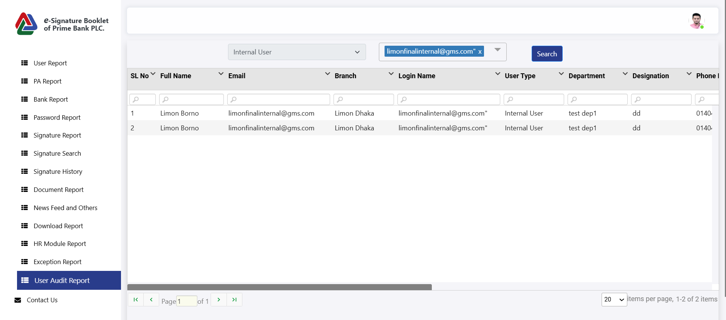

* **Click "Report,"** then select the **"User Audit Report"** submenu to view all user audit reports.
* **Select User Type**: The **User Type** field is enabled. Choose either **Internal** or **External**.
* **Enable User Name**: Once a **User Type** is selected, the **User Name** field becomes active.
* **Disable User Type**: After selecting a **User Name**, the **User Type** field is automatically disabled.
* **Click "Search"** to display all **User Audit Reports** based on the selected user.

**Contact Us**

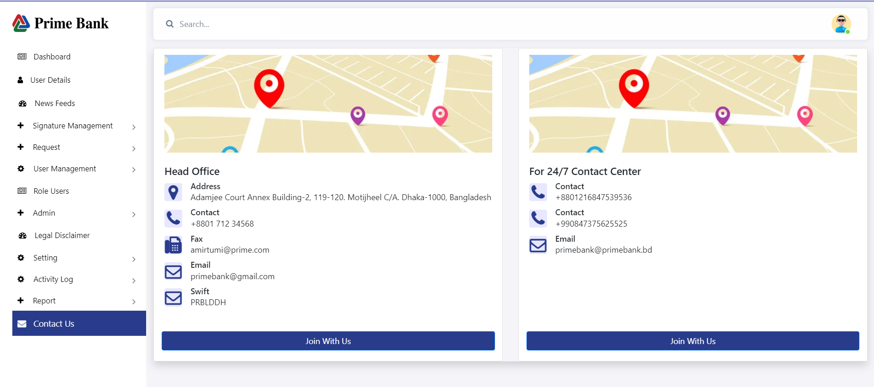

* Click "Contact Us" to show all contact information for Head Office and the 24/7 Contact Center.

**Thanks….**